Installing the Roadkill Reporter app

​Please be aware, the Roadkill Reporter uses the ArcGIS Survey123 app.

Installing the Roadkill Reporter
To install the Tasmanian Roadkill Reporter, you first need to follow these 3 easy steps.
1. Download the ArcGIS Survey123 app from an app store onto your smartphone or tablet (Search for “Survey123”).
​

​
2. Once the download is complete, go to the Survey123 app icon on your device.
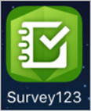
Open the app and click “Continue without signing in". You will need to have location services on.
​​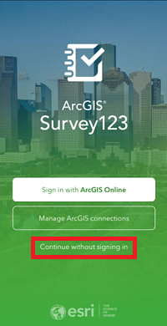
3. The first time you use the app, you will need to download the Tasmanian Roadkill Reporter.

If you are on a mobile or tablet, use this link. https://survey123.arcgis.app?itemID=7a0a5d38928a4132b5a238e575d0257e

If you are viewing on a computer, click the QR code option on the right side of the search bar.​
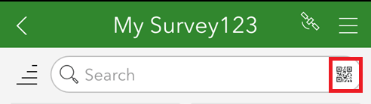
Scan the following QR code using your phone or tablet.
When the download is completed, you will see a record collection page.
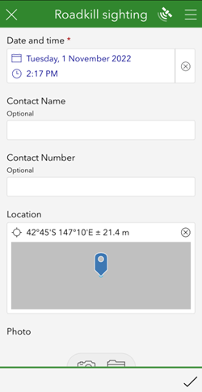​

Using the Roadkill Reporter app
​To make a roadkill report, fill in the report form – contact name and number are optional.
Date, time and location can be changed if you want to make a report later once you have reached your destination.
To make a report away from the site of the roadkill, touch the map in the report to bring the map up into full-screen mode, move the map around by touching and dragging on the screen until the cursor sits at the appropriate place on the map for where the roadkill was seen.
If you stopped to make your report and took a photo, upload the photo of the animal.
IMPORTANT: please only take a photo if it is safe to do so.
If you are unsure about the type of animal, click on the Roadkill Species Guide in the report form or see it on our website.
After you complete the report form, select the tick in the bottom right corner.
The Survey Completed message will appear, with three options
- Send now - if your device is in range and online;
- Continue this survey - if you want to edit your report; or
- ​Save in outbox - if you are offline. When you are back in range or online you can then go to the outbox and submit your surveys.
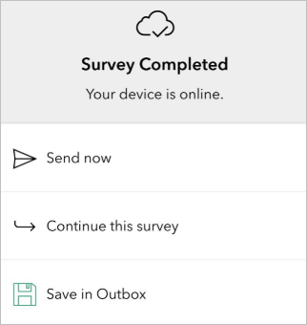
Once submitted the Sent icon will show a number that indicates the number of surveys sent.​
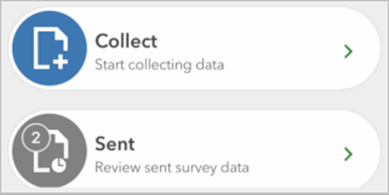

All subsequent reports
The next time you open the Survey123 app you will select the “Continue without signing in” option but you will now see the Tasmanian Roadkill Reporter survey icon.
Click on it to submit more reports.
Click “Collect” at the bottom of the screen to begin making your report​


