6 January 2023

Dear stakeholder
Roadkill has wide-ranging consequences, not just for threatened species conservation and animal welfare, but also for road user safety and insurance, and amenity and tourism experience. However, without data it is difficult to understand how significant the problem is and to determine how and where to direct mitigation.
The Department of Natural Resource and Environment Tasmania (NRE Tas) has developed an in-house roadkill reporting app to enable ongoing collection of roadkill data by members of the public and road managers.
This new app will enable the collection of a range of species, including feral species. All data will be uploaded to the Natural Values Atlas (NVA) and the LIST promptly to allow regular interrogation of data. NRE Tas is confident this new app will provide the ideal forum for roadkill data collection now and into the future.
Roadkill is a challenging issue to manage that relies on collective efforts and while the new roadkill reporter app will be available for anyone to use, it is our road workers who could really make the difference in the quantity and quality of the data collected. Workers removing roadkill from the road could also report these using the new app. Councils can tag their reports with the council name to allow them to download reports their workers have submitted from the NVA, or interrogate the data on The LIST. This will allow councils to take a proactive position on mitigating roadkill in their jurisdiction and enable an informed response to queries from their ratepayers.
I also encourage you to share information about the app on your social media channels. Instructions on how to download and use the new app are attached and can also be found on the NRE Tas website (https://nre.tas.gov.au).
I thank you in advance for your ongoing support of roadkill data collection.

Yours sincerely

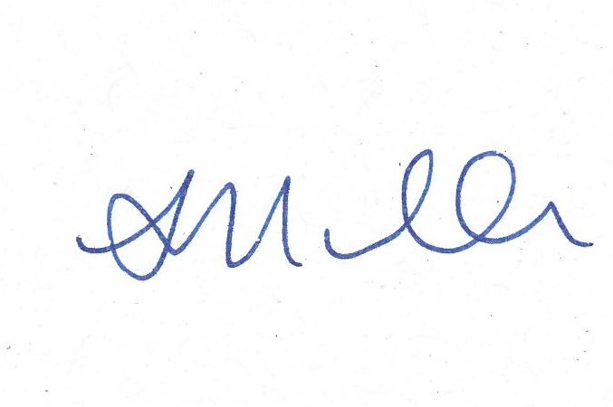

SOPHIE MULLER
DEPUTY SECRETARY
ENVIRONMENT, HERITAGE AND LANDS

