PROGRESS REPORT FOR SAFFIRE/ WILDCARE

Time period: May 2018 – May 2019

Grant provided for salary for research veterinarian for 2 days/ week

Research veterinarian: Ruth Pye BVSc, MVS (Conservation Medicine), PhD

Ruth is continuing to work as the research vet for the Tasmanian devil immunology research group at the Menzies Institute for Medical Research thanks to funding provided by Saffire through Wildcare.

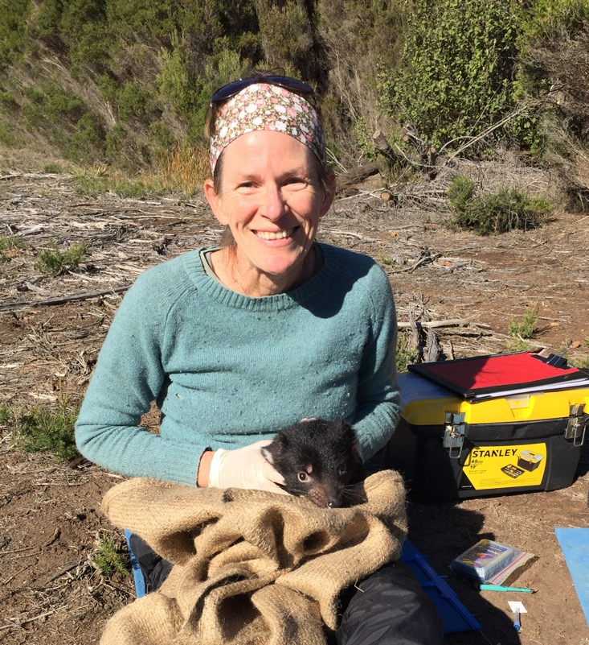

SUMMARY OF RESEARCH VETERINARIAN ACTIVITIES 2018-2019:

DFTD immunisation trials on devils for wild release, and post-release monitoring

Stony Head

In 2016, 33 devils immunised against DFTD were released at Stony Head on the mid north coast. Monitoring of the site by the Save the Tasmanian Devil Program is continuing.
The monitoring trips for the previous 12 months occurred in May 2018, August 2018 and March 2019. Ruth joined each of these 8 day trips to collect blood and tumour samples from the immunised devils and all the incumbent devils that were trapped.

Once analysis of these samples is complete the results will be compiled for publication.

Buckland

In June 2018, 24 devils were immunised and released at Buckland, on the east coast.
Ruth assisted with the health checks and immunisations of the devils for two days during the release.
The STDP carried out a monitoring trip at the site one month later and will do so again in June 2019. Blood samples from immunised and incumbent devils will be collected for analysis by the Menzies devil group.

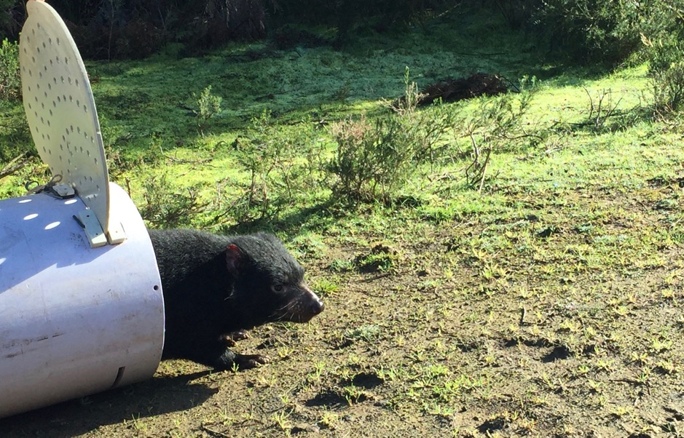
Captive devils at Richmond

The Menzies devil group currently has 6 devils at a facility near Richmond for research purposes. Ruth, as research vet, is responsible for the health and welfare of these devils, and liaises closely with the Richmond devil keeper.

Ruth collects blood samples from the devils for the research group, and performs procedures such as trial immunisations on the devils.

In February 2019, an immunisation trial against DFT2 (the second transmissible cancer found to affect the devils) was carried out on two of the Richmond devils.
This trial has yielded some promising results which will be published in due course.

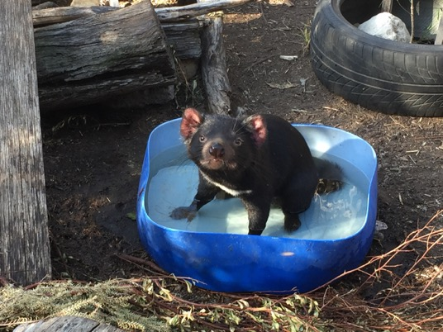

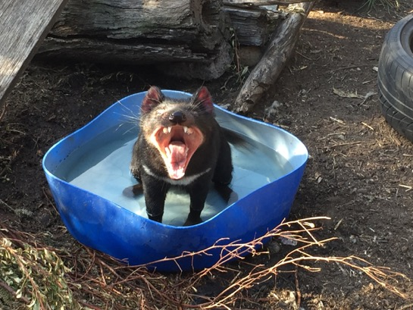

Awards, presentations, workshops, community engagement 2018-19

Menzies Institute for Medical Research “Ten of the Best Award” 2019 for first author publication of “Immunisation strategies producing immune responses against DFTD in 95% of Tasmanian devils destined for wild release”, Frontiers in Immunology

Visit and presentation to Dr Liz Murchison’s Transmissible Cancer Group in Cambridge, UK; July 2018

Presentation on DFT2 at the Wildlife Disease Association Australasia Conference, Bali, October 2018

Attendance at Wildlife Health and Pathology Short Course, Taronga Zoo, Sydney, February 2019

Presentation on devils and DFTD at Lansdowne Crescent Primary, Hobart, August 2018

Plans for June 2019 onward

Complete sample analysis and results interpretation from the Stony Head field trips and collate these for publication

Complete the DFT2 immunisation trial on captive devils and prepare results for publication

Fulfil obligations as one of the Chief Investigators on the ARC Discovery Grant “Does host MHC-I type determine rejection of devil facial tumour disease?” if the application is successful

Continue working closely with members of the devil immunology group at Menzies – e.g. lab meeting participation; project discussions and facilitation

Continue care of and sample collection from the captive devils at Richmond

Continue to liaise with the Save the Tasmanian Devil Program and research collaborators (Dr E. Murchison, Cambridge, UK; Dr H. Siddle, Southampton, UK; Dr C. Hogg, USyd; STDP; Dr R. Hamede, UTas) with respect to sample requirements, sample collection, sample analysis and research questions

Ruth Pye BVSc, MVS (Conservation Medicine), PhD
Tasmanian devil immunology group, Menzies Institute for Medical Research, Hobart, TAS 7000
E: ruth.pye@utas.edu.au

