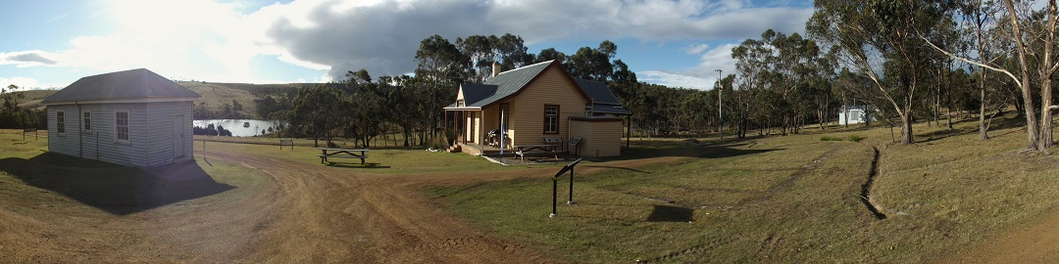

Bruny Island Quarantine Station Newsletter Summer 2018-p.3

Brickwall extension:
We have made a small extension to our low brick retaining wall south of the headhouse. Many thanks to Ian Overell for his skills that will now enable much safer acess for people and vehicles.
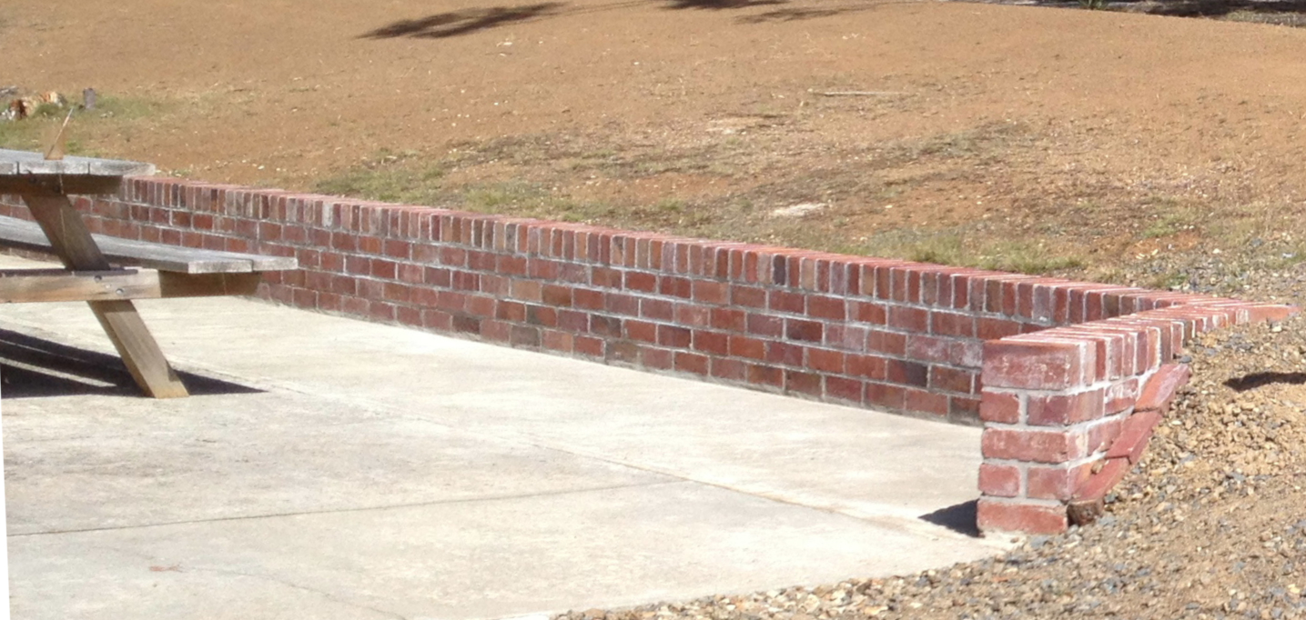
Caretakers, extended hours and visitors:
We have filled all caretaker spots during the last year with some returnees and new folk. The Station is a beautiful spot to relax and volunteer. This year has been our second full winter season of opening. As visitors increase into Tasmania across our cooler seasons, we have had our dividend into the Station with over 600 winter visitors.(and over 3400 summer visitors in 2017/18!)
Visitors have been impressed with our expert caretakers and the work that has been accomplished around the site.

Some more images….
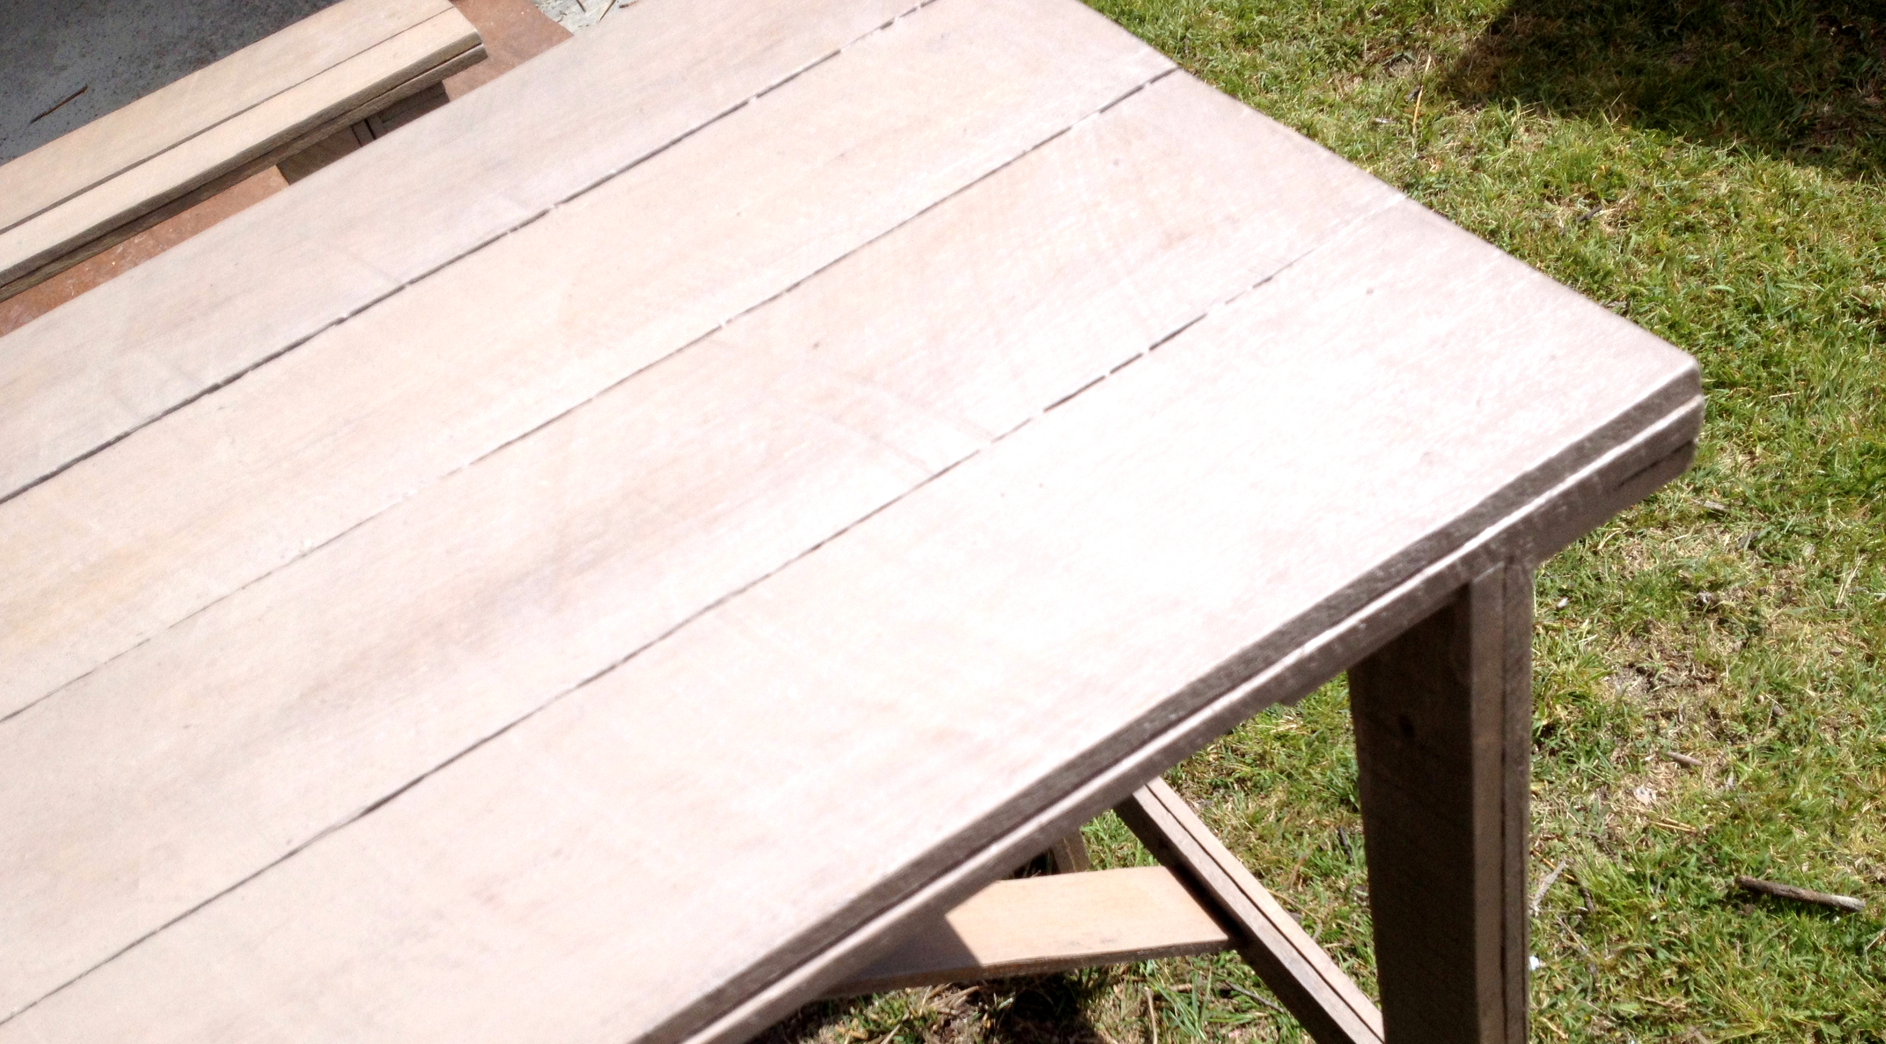
Some fine reproduction WW1 carpentry by Craig, many thanks to Watsons Timber.

The wildlife continues to assume our visitors…
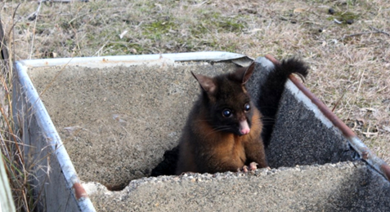

…caught in the (trough) act…

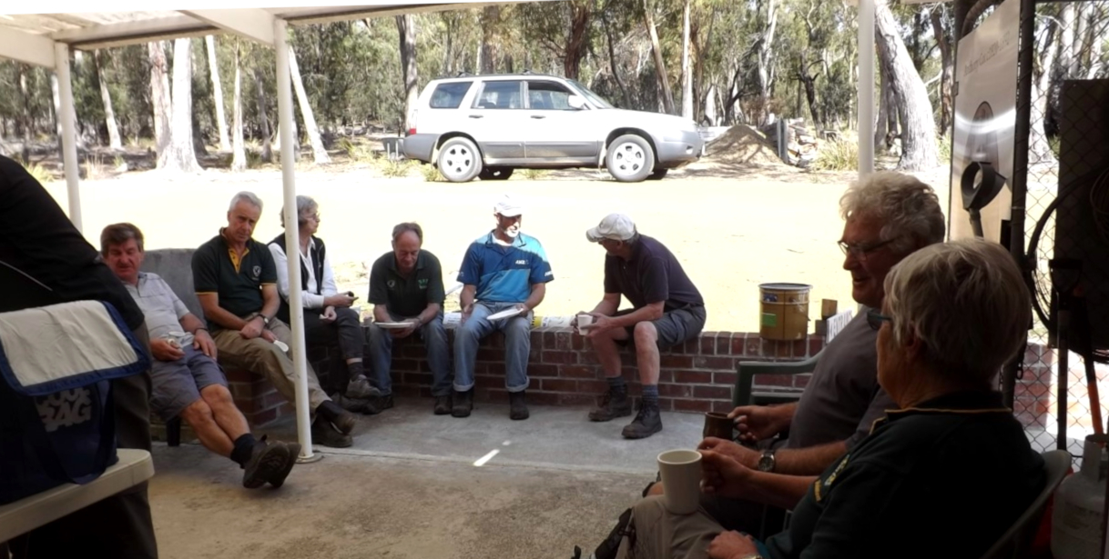
…and finally every working bee needs a good lunch and planning session…

