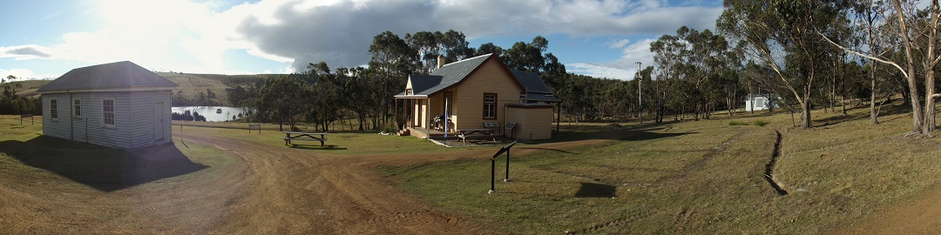

Bruny Island Quarantine Station Newsletter Summer 2018-p.2

School groups:
Woodbridge School visited recently via their vessel, the Penghana. They toured the grounds and are thinking about future uses for the Station as a site for learning. Conversations have begun with Bruny Primary School for similar use of our site.
Bench seat plaque:
We are proud to recognise the support and work of Jannelle, one of our valued caretakers who unfortunately died in a motor accident in January this year.

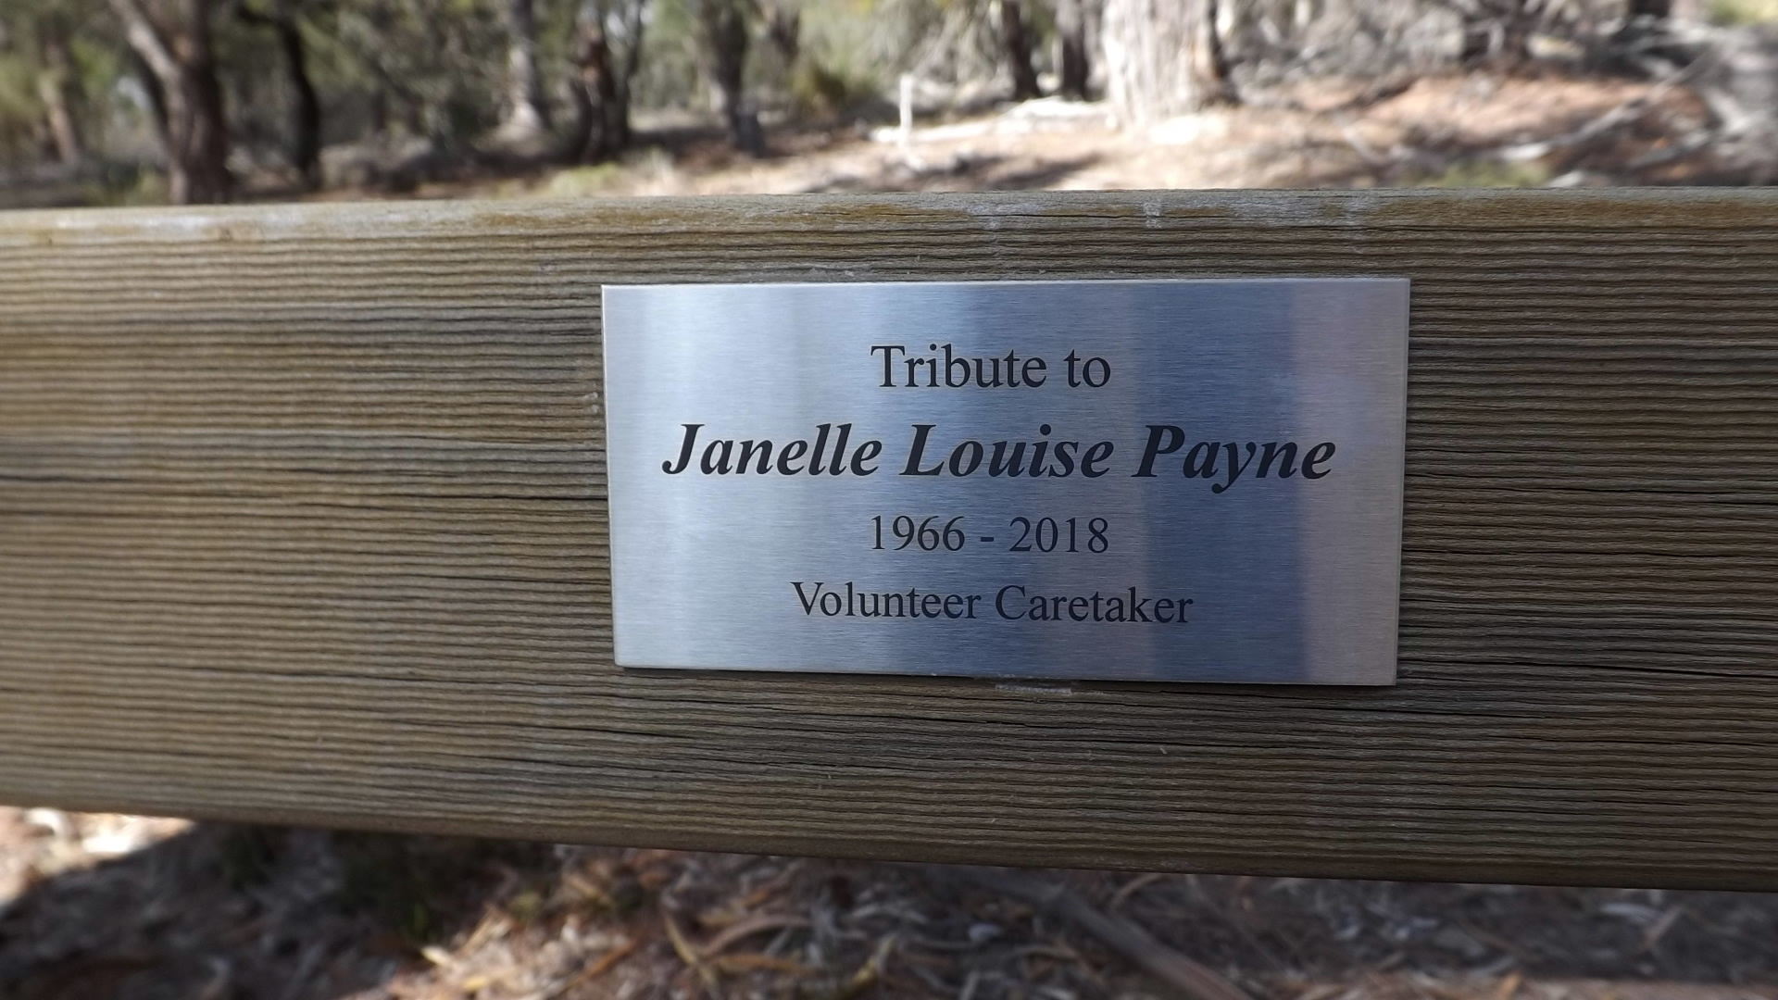

Pallisade fence:
During the last year many visitors have been interested in the paling display that describes the height of the original pallisade fence. This fence attempted to keep “ guests” within the quarantined medical area. We have photos of the original fence. It was wooden, about 8 feet high, with palings fixed on the inside to possibly deter any “climbers”. After discussions with Parks we will reinstall a small section of this original perimeter pallisade fence off the south east corner of the cleansing room. Judging by the interest shown by the public to date this small fence section will help boost the interpretation of the Station significantly.

Cumbungi update:
Introduced invasive cumbungi seems to be under good control in the lower dam near the road and should now require minimal underwater pruning to stop further problems.
Armistace:
We were successful in our application for a small Armistice Grant which enables us to create an active monument and visible tribute to the soldiers who passed through the Quarantine Station on their return home from WW1. We hope to erect a 'bush mess' (copied from a photo taken 1919) and a replica tent of the era. Kathy has been busy with research as she endeavours to find all the names of the soldiers who passed through the station. We will be holding a commemorative day on 10 February 2019. The date of the arrival of the first troopship which brought soldiers to the station to be quarantined on their return, due to the influenza pandemic.
Committee:
This year we again filled all committee positions and we welcome Cindy and Elise to the FOBIQS committee. We are fortunate to have Kathy as our President, Cindy as Secretary, Richard as Treasurer, Rob in Publicity and Paul, David and Elsie as committee members. Peter is still with us but has stepped slightly aside this year as he helps with Wildcare as Co-chair.
Visiting Groups:
Two separete groups from the Hobart Walking Club recently enjpoyed a relaxing day on the station and in our reserve bush. Other groups to vsiit the station in recent months include UTAS, Probus, and the Cruising Yacht Club.

