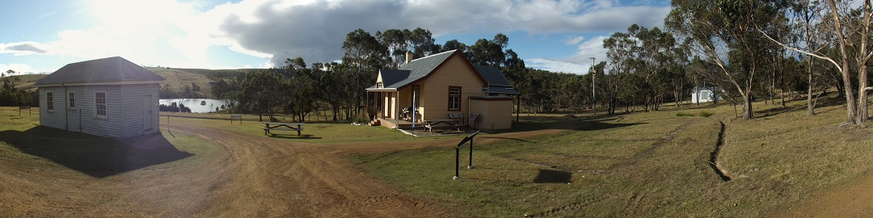

Bruny Island Quarantine Station Newsletter Summer 2018-p.1

Working Bees and Maintenance:
Recent working bees have been conducted with the help and leadership of Brett Knowles, Scott Thornton and skilled “mainland” Parks staff. One job was to remove dangerous regrowth from the upper dam wall. The regrowth was risking the integrity of the dam wall.
We thank Jenny Mudge (Parks) who has assisted with several safety audits resulting in power supply maintenance and improvement of on site processes for events.
With guidance from Heritage Officer Peter Rigozzi, a section of the “barracks” floor has had its second major renovation in its 100 year life. Rotten joists and bearers being replicated and replaced. Many thanks to our volunteer caterers who have kept worker bees fueled up with food and drinks.
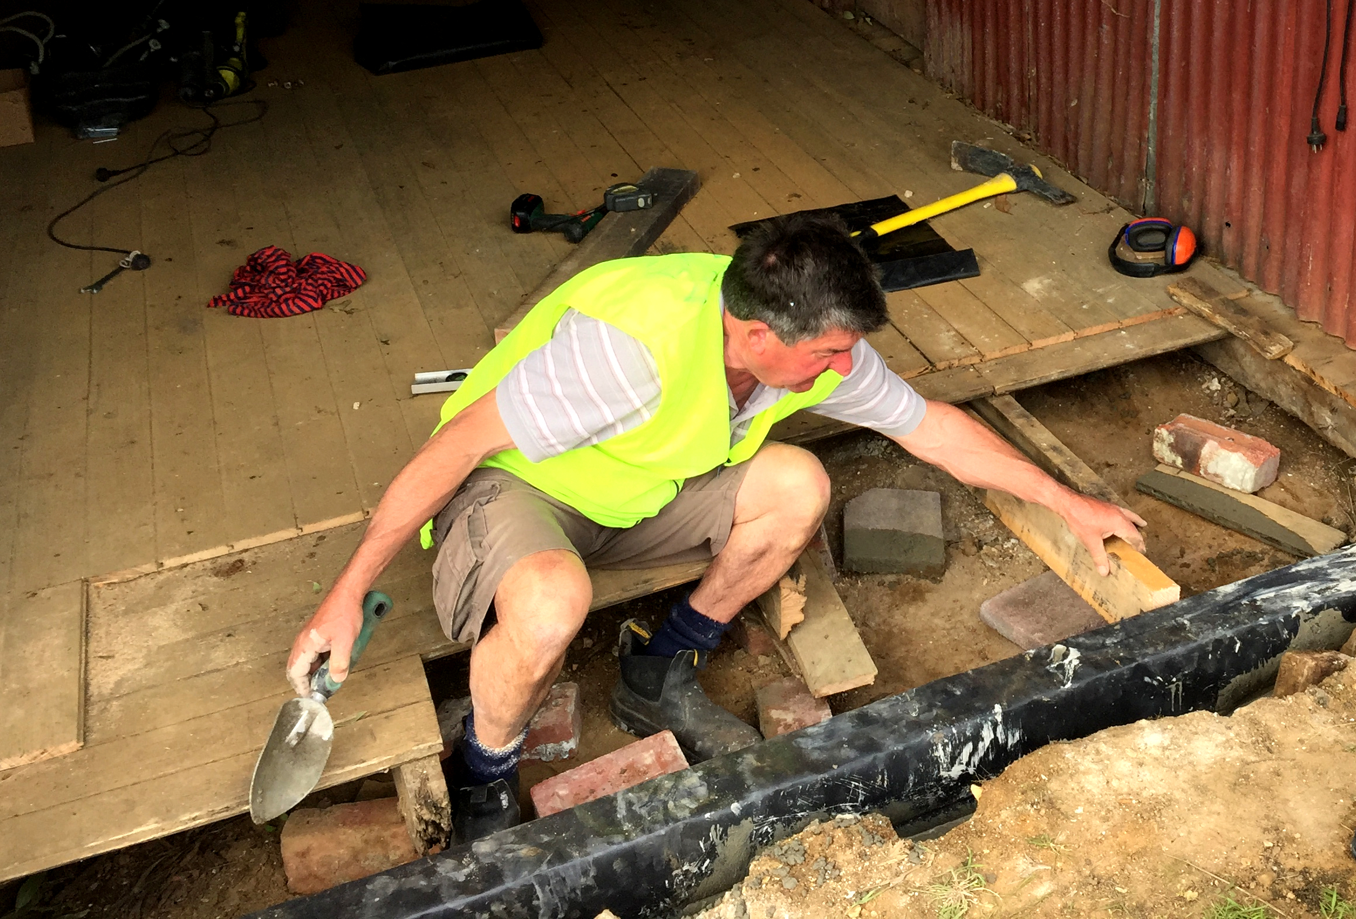
Peter working on the barracks floor.
New tools:
Some new tools have been purchased for volunteers and a shadow board constructed for easy access and identification.
Orchids:
Malcolm Wells completed his ‘native orchid survey' and we look forward to supplying information, photos etc. in the coming year. Many thanks Malcolm.

Cleansing and Painting:
A long term paint removal and repainting project of the small cleansing room is now finished. Many thanks to David and Jenny Caldwell, caretakers and helpers! The building is currently in the process of having its interpretation upgraded and the result will be a stunning model for all .
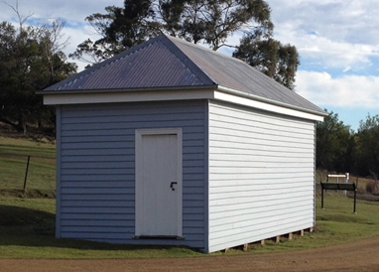
Science Fun Day:
Over 100 people attended our third annual Bruny Island Science Fun Day on October 14th. Warm weather and blue skies enabled young and old to enjoy science activities and visiting guest speakers. Key sponsorship from Inspiring Australia, Parks, Bendigo Community Bank, Biosecurity Tasmania, Kingborough Council and many local businesses ensured success.
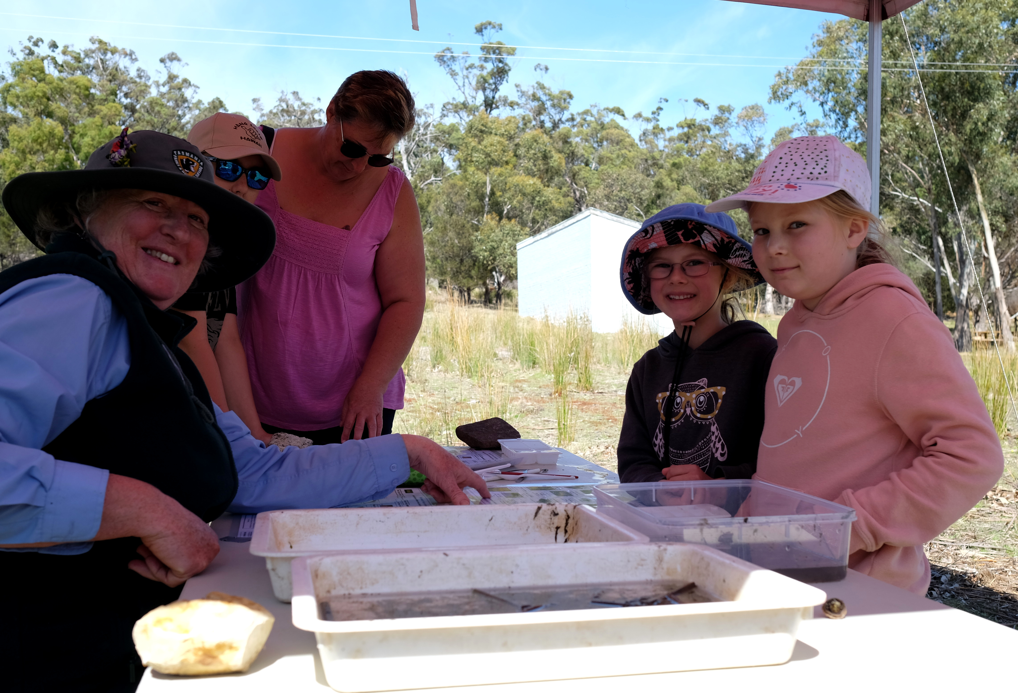
Volunteer Debbie with invertabrate scientists!

