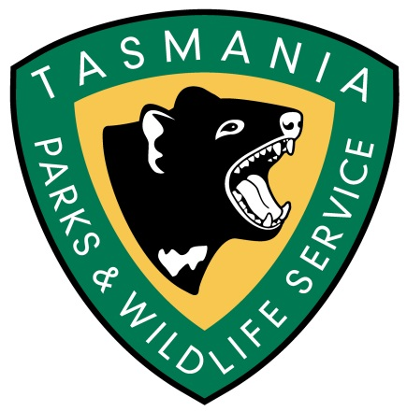

Mount Field National Park Campground
Volunteer Caretaker Program 2018-19

INFORMATION DOCUMENT
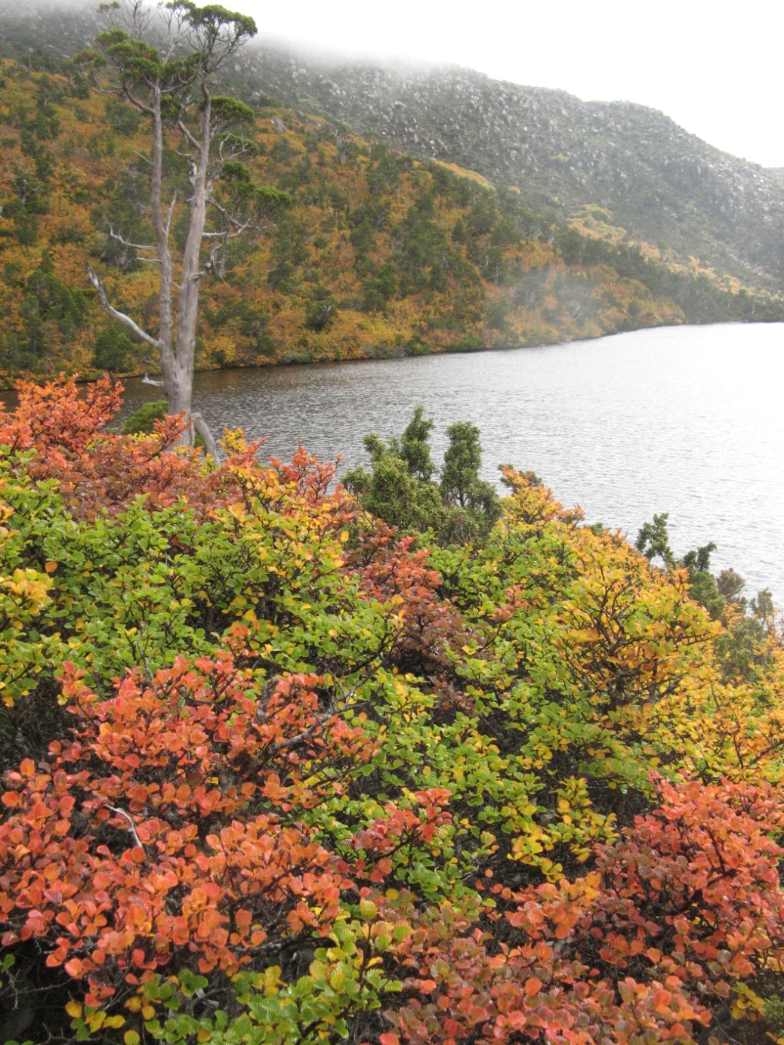
Introduction
The Mt Field National Park Campground Volunteer Caretaker Program provides opportunities for volunteers to enjoy living in and assisting Parks and Wildlife Service within the World Heritage Area listed Mt Field National Park.

Volunteer Caretakers will provide a physical presence; provide visitor information about the Mt Field National Park Campground, natural history of the area, carry out minor maintenance and assist with coordination of other Parks and Wildlife Services (PWS) activities at the site. There may also be an opportunity to join the Wildcare Friends of Mt Field Volunteer Group on one of their monthly working bees, held on the third Saturday of each month.

During the week, caretakers will have time to read/write, walk and fish and to explore Mt Field’s many attractions. These include waterfalls, tall trees, alpine areas, glacial lakes, rainforest and the many species of wildlife that abound in the area.

The opportunity to volunteer at Mt Field National Park, may serve as an ‘apprenticeship’ for those people seeking volunteer positions at other PWS locations.

About Mt Field National Park
Mt Field is one of Tasmania's most diverse national parks. From the tall forests at the base of the mountain to the unique alpine plants at its summit, this national park offers the visitor an array of natural wonders. The wheelchair grade walk to Russell Falls is the most popular track in the park. Through a forest of towering tree ferns, this level path will take you to the beautiful Russell Falls. For many people, this three-tier waterfall is the prettiest in Tasmania.
The winding road that leads to the higher slopes of the mountain passes through an ever-changing succession of plant communities. Interestingly, Mt Field is unusual in that plant diversity increases with altitude. The Pandani Grove walk around Lake Dobson is the perfect place to discover some of the park's bizarre alpine species. With patience, and a little luck, you may even see a platypus in the lake. Early morning and late evenings are the best times to be on the lookout.
For Hobart residents, Mt Field is a close and well-loved skiing venue. Often during the winter months, tows operate on the slopes; however, since there is no guarantee that they will be operating it is best to check the Southern Tasmanian Ski Association web site, at http://stsa.webbed.com.au/ or phone 6288 1166. Downhill, snowboarding and crosscountry skiing are popular. From the ski huts, a well-marked track leads you to the spectacular Tarn Shelf, a stunning, lake-ridden shelf that was carved out by the force of glaciers from the previous Ice Age. During autumn, the slopes of the mountains which back onto Tarn Shelf become a riot of colour as the fagus, or decidious beech, turns gold and red and orange.
Among the many natural heritage values to be found within the park are:
- 13 plant species recorded as rare in Tasmania;
- a swamp gum (Eucalyptus regnans) and stringybark (E. obliqua) wet forest community that is also of outstanding display value;
- easily seen barred bandicoots (Perameles gunnii), a mammal listed nationally as vulnerable;
- complex karst features of high geoconservation value;
- outstanding glacial features such as K Col and the Lake Fenton blockstream;
- at least four invertebrates that are listed as either rare, threatened or vulnerable at the State level;
- wet sclerophyll forest communities of high conservation value;
- alpine and subalpine communities of high conservation value; and
- the Lake Fenton / Lady Barron Creek drinking water catchment which provides 20% of the domestic water supply for Hobart.
Additionally the park encompasses many cultural heritage values, including:
- Along with Freycinet National Park, Mt Field Nat. Park is Tasmania's oldest national park, which is also one of the oldest reserves in Australia;
- known Aboriginal heritage values;
- an important part in the development of the Derwent valley region; and
- many sites and artefacts of historic cultural heritage significance such as Twilight Tarn hut.

Volunteer Caretaker Program Dates and Duration
The program will commence in December and will extend to approx. April 2018.

Volunteer Caretaker Duties Will Include
- Meeting and greeting visitors at the Campground
- Advising campers of accommodation options in the campground, famil of the site, and fees payable (but not the actual collection of camping fees or National Park pass fees)
- Providing visitors with information about walks and other activities to do in the NP
- Carry out minor maintenance of tasks identified in the approved work program
- Reporting issues such safety hazards and bushfire risk to PWS Mt Field staff.
- Other tasks identified and appropriate to the capacity of individual Volunteer Caretakers.

Volunteer Caretakers Will Not Be Required To
- Be involved in any law enforcement activities, or confront visitors over any such issue unless there is an immediate risk to personal safety.
- Collect camping fees

The Parks and Wildlife Service will provide
- Full Induction regarding the Volunteer Caretaker Role on first day of placement
- Gazebo, maps, printed information for visitors to peruse
- Any tools and equipment necessary for minor maintenance duties
- Items of clothing to identify Volunteer Caretakers (VEST, hat/cap and name badge)
- First aid kits
- Emergency communications – staff support in the event of an emergency
- Ongoing support by phone and in person as needed
- Debrief on conclusion of volunteer placement

Volunteer Caretakers will be expected to provide
- Their own accommodation i.e. caravan/tent/motor home
- Food for the duration of their duty (closest large supermarket at New Norfolk)
- All clothing apart from uniform items (see above) (bring work clothes in case needed)
- All bedding and linen, cooking, cutlery, crockery
- Transport to and from Mt Field National Park

Accommodation
Volunteer Caretakers will be required to provide their own accommodation, and this will be sited at the entrance to the Mt Field National Park Camping Ground.

4G mobile phone coverage is available for the area

Qualifications and Selection Criteria
Volunteer Caretakers will not require specialist or trade qualifications, but general knowledge of the area, communication and practical skills. If, however, you have specialist qualifications that you consider may be useful (eg carpenter, electrician, trades skills) please advise us on the program application form. Special skills in arts, education and culture are highly regarded and should be mentioned.

Volunteer Caretakers will be selected according to how well they meet the following selection criteria:
- Ability to live and work in a semi-remote location, with limited ‘home comforts’ for the two week period
- Ability to communicate well with a broad range of visitors
- Possessing a broad range of practical skills appropriate to tasks agreed
- First aid qualifications or medical knowledge highly desirable for at least one member of each team
- Ability to live and work in a team environment including working effectively with rangers
- Knowledge of, or the ability to rapidly acquire knowledge of the cultural and natural history of Mt Field National Park

Training
The Parks and Wildlife Service will conduct a full induction and familiarisation sessions for caretakers on site before starting. All volunteers are required to attend the induction

Wildcare Inc. All applicants are encouraged to join WILDCARE. www.wildcaretas.org.au

Work Health and Safety
The provision of a safe working environment and safe working procedures is mandatory for all works carried out by PWS. The Volunteer program at Mount Field National Park will be carried out according to all current safe-working guidelines. Volunteers will be made familiar with these procedures during the Induction and will be expected to adhere to them.

Conditions of Engagement in Volunteer Program
All people volunteering with Parks and Wildlife Service are required to conduct their duties in accordance with the State Service principles and Code of Conduct.
Agency expectations will be explained at the Induction.

How to Apply
See separate Application Form

Closing Date: COB Sunday 30 September 2018

