CAPE BRUNY LIGHT STATION
VOLUNTEER CARETAKER & WEATHER OBSERVER PROGRAM
October 2018. to May 2019

INFORMATION BOOKLET

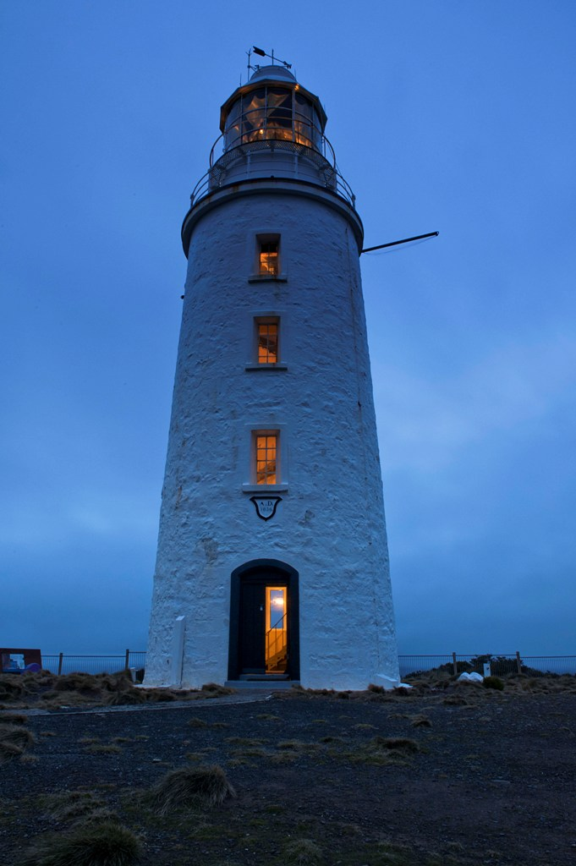
Photo by Volunteer Caretaker Ron Fehlberg

Introduction
Following a series of mishaps and shipwrecks south of Bruny Island in 1835, Governor George Arthur agreed to erect a lighthouse to guide vessels past Bruny Island. When it was first lit in March 1838 Cape Bruny was Tasmania’s third lighthouse, and Australia’s fourth. It is now the second oldest lighthouse in the country and the longest continually staffed (158 years). The Cape Bruny light was lit for the last time on 6 August 1996 and replaced by a solar powered light nearby.
Along with most other Tasmanian light stations Cape Bruny was transferred from the Commonwealth Government to the state Government 1 May 1998. In December 2000 it was added to the South Bruny National Park. The lightstation was maintained by a Leasee Caretaker until 2011, when Parks and Wildlife Service Tasmania, established a Volunteer Caretaker and Weather Observer Program. This program now runs year round, in 2 monthly placement blocks. (Occasionally 1 Month). The Volunteer Caretakers live onsite. They provide a welcome presence and information to visitors and assist with the running and general maintenance of the site.
Program Dates and Duration (Summer October 2018 to May 2019)
October and November will be a 2-month placement, followed by December, January, February, March being 1-month placements, then back to 2-month placement for April and May. In addition, over the summer short 4-day placements will be made, to provide a break for the current Volunteer Caretakers This is to offset the busy nature of the Volunteer placement given the large number of visitors coming to the site each day in summer.
The Volunteer Placement Contract is with Parks and Wildlife Service for the Caretaker Role and a separate agreement / contract with BOM to complete 2 weather observation each day at 9am and 3pm. The BOM provides a 2 day weather observation training session based in Hobart just prior to volunteers commencing on site at Cape Bruny. The outgoing Volunteer Caretakers will be onsite on the changeover/induction day to mentor next Volunteer Caretakers in both regular duties as Caretakers and about the weather observation duties.

…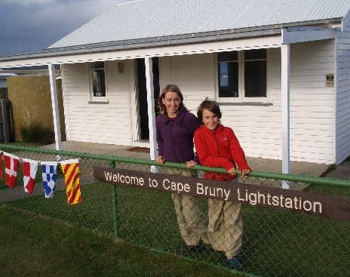…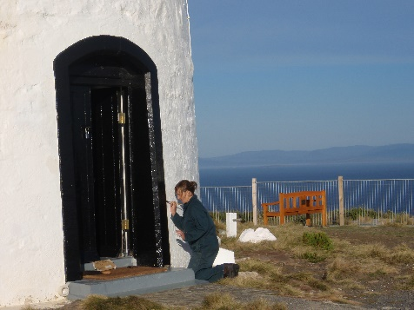

Volunteer Caretaker Duties will include:
- Daily routine am and pm checking of and set up of site ready for visitors
- Conduct duties within a ‘split shift’ concept to ensure a break is taken in the middle of day
- Carry out weather observations for the Bureau of Metrology at 9am and 3pm daily.
A 2 day training session is provided in Hobart prior to start of volunteer placement
- Meet and greet visitors arriving at the Cape Bruny Lightstation precinct as is reasonable
- Ensure the visitor infrastructure incl. public toilet on site is kept clean and serviceable. Also includes the museum, houses and workshops
- Report any malfunction or maintenance concerns to the Ranger as soon as possible
- Provide helpful and professional public face for Parks and Wildlife Service at Cape Bruny
- Work collaboratively with the commercial operator running lighthouse tours on site
- Provide visitor information regarding services and opportunities available at Cape Bruny, the South Bruny National Park, and Bruny Island as a whole
- Cut grass around the precinct as required to maintain a traditionally neat & tidy appearance
- Maintain the sites power and water supplies through checks of generator and solar systems, water tanks, ensuring any report of issues goes to Ranger as soon as is noticed
- Carry out minor maintenance of building infrastructure, signs and walking tracks as directed by the Ranger
- Maintain small vegetable garden to provide fresh vegetables for yourself and future CT’s
- Carry out litter pick up and coordinate the disposal of rubbish from site through the Rangers
- Act as first responders in case of an emergency. Contact 000 or 131444 or Ranger as needed
- Monitor visitor numbers and impacts
- Liase with the Ranger on day to day operations
- Provide feedback on your departure to Ranger and the Regional Volunteer Facilitator
- Conduct all duties and activities in accordance with the principles of the Tasmanian State Service Code of Conduct and the policies and procedures of the Department of Primary Industries, parks, Water and Environment.

Volunteer Caretakers will not be required to:
- Be involved in any law enforcement activities, or confront visitors over any such issues, unless there is an immediate risk to personal safety.
- Be involved in assisting visitors in parking or moving around the car park
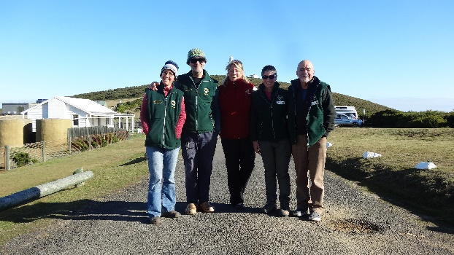………….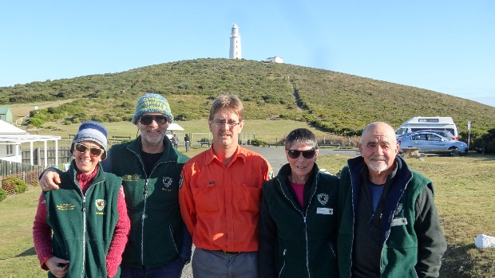
Figure 2 & 3: Volunteer Caretaker Changeover and Onsite Induction
On left Volunteer Caretakers Anna Broome and Adam Gittins with Regional Volunteer Facilitator Pip Gowen
And Ranger Bernard Edwards and Chris and Tony Barber
The Parks and Wildlife Service will provide:
- Accommodation at one of the ‘Lighthouse keepers Residences;’
- Onsite Induction and Safety Briefing
- Support by phone and in person as needed
- Emergency communications
- First aid kits
- Any Personal Protective Equipment (PPE) tools and equipment necessary for minor maintenance duties and
- Items of clothing to identify Volunteer Caretakers (VEST, hat and name badge).
- Voucher for one return ferry trip Kettering to Bruny Island.
- Consumables used in maintaining and cleaning visitor infrastructure
- Pellets for pellet heater as needed and water delivery to site if water tanks run low

Volunteer Caretakers will be expected to provide:
- All food and consumables for the duration of their placement
- All bedding and linen (consider electric blanket or hot water bottles)
- All clothing apart from uniform items (see above)
- Sturdy work boots
- Old work clothing or overalls
- Own vehicle for transportation to Cape Bruny
- Volunteer Registration and emergency contact details
- Police Check (Regional Volunteer Facilitator will provide form)
- Internet access devices as the connectivity in the house is very limited

Accommodation
Volunteer Caretakers, will be accommodated in the Lighthouse Keepers Residence. One of 2 Keepers houses on site
- well-appointed kitchen with all utensils, electric hot water, fridge, microwave and stove
- Pellet fired heater in kitchen/dining area
- 3 bedrooms, 1 with a double bed and one with two single beds
- another single bed in the room currently used as the BOM weather office
- bathroom with hot shower, hand basin and toilet
- electricity powered by solar with backup from generator
- telephone PWS landline on site OK for limited use and mobile option possible in carpark
- laundry with washing machine and basin
- parking close to the quarters

The Volunteer Caretakers will have sole occupancy of the Residence, except in an emergency where other PWS staff or Emergency Services may need space. On occasion PWS staff will visit site during your placement and when on site require access to the kitchen and other facilities.

Qualifications and Selection Criteria
Volunteer Caretakers will require and ability to live remotely in challenging weather conditions and to be comfortable being on this high visitation site with a significant number of visitors during the day. (Summer visitor numbers approx. 800 to 1,200/day). The evenings after sunset are a quieter time on site to enjoy the peace and the natural values of the site. This is a very people focused volunteering position. You do need to like and appreciate the diversity of visitors coming to Cape Bruny.
Also important to have general knowledge of the area, communication skills and practical skills.
SELECTION CRITERIA
Volunteer Caretakers, will be selected according to how well they meet the following selection criteria:
- Ability to live and work in a semi-remote location, with limited ‘home comforts’ for 2 months
(1 month) Including in difficult weather conditions ie windy with potential of changing temperatures

- Ability to communicate well with a broad range of visitors and large number of visitors expected at Cape Bruny

- Knowledge of, or the ability to rapidly acquire knowledge of, the cultural and natural history of the South Bruny National Park and heritage of Lighthouse Station

- Practical skills appropriate to undertake routine maintenance tasks. An ability to be comfortable with routine toilet cleaning tasks – all Personal Protective Equipment is provided for your safety and comfort.

- Ability to take direction from Ranger and yet be flexible if their work schedule means plans need to change.

- First aid qualifications or medical knowledge highly desirable for at least one member of each team.
Site Induction and Volunteer Change Over
The Parks and Wildlife Service will conduct an Induction and Safety Briefing for Caretakers on site on the day your placement begins. All Caretakers are required to attend this induction. The ‘Outgoing’ Volunteer Caretakers will often stay on site for that day to assist with the Induction and Weather Observation reporting
Occupational Health and Safety
The provision of a safe working environment and safe working procedures is mandatory for all works carried out by PWS. The Volunteer program at Cape Bruny will be carried out according to all current safe-working guidelines. Volunteers will be made familiar with these procedures during the Induction and will be expected to adhere to them.
Conditions of Engagement in Volunteer Program
All people volunteering with Parks and Wildlife Service are required to conduct their duties in accordance with the State Service principles and Code of Conduct. Agency expectations, will be explained at the Induction.

How to Apply
If you are interested in taking part in the Volunteer Caretaker Program, complete the Application Form. Please be aware that completion of the application form does not guarantee a place on the program.
Closing Date
Applications for placements in the Program will close on: Monday (at 9am) 17 September 2018.
Selection - notification
All applications will be considered. Applicants will be notified if they have been successful by COB Friday 21 September 2018. Please be aware that there continues to be a very high interest in volunteering at Cape Bruny. My apologies in advance as there is likely to be more interest than places available. I am more than happy to provide feedback and or discuss other volunteering options as we have many wonderful sites and options available

Enquiries and completed Applications to:

Pip Gowen
Regional Volunteer Facilitator (South)
E: pip.gowen@parks.tas.gov.au
M: 0427 648 463

