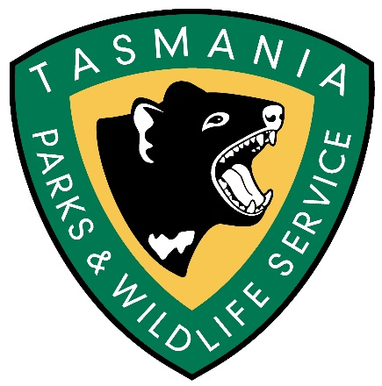

Department of Environment Parks, Heritage and the Arts

Cockle Creek
Volunteer Caretaker Program
2018 19

APPLICATION FORM

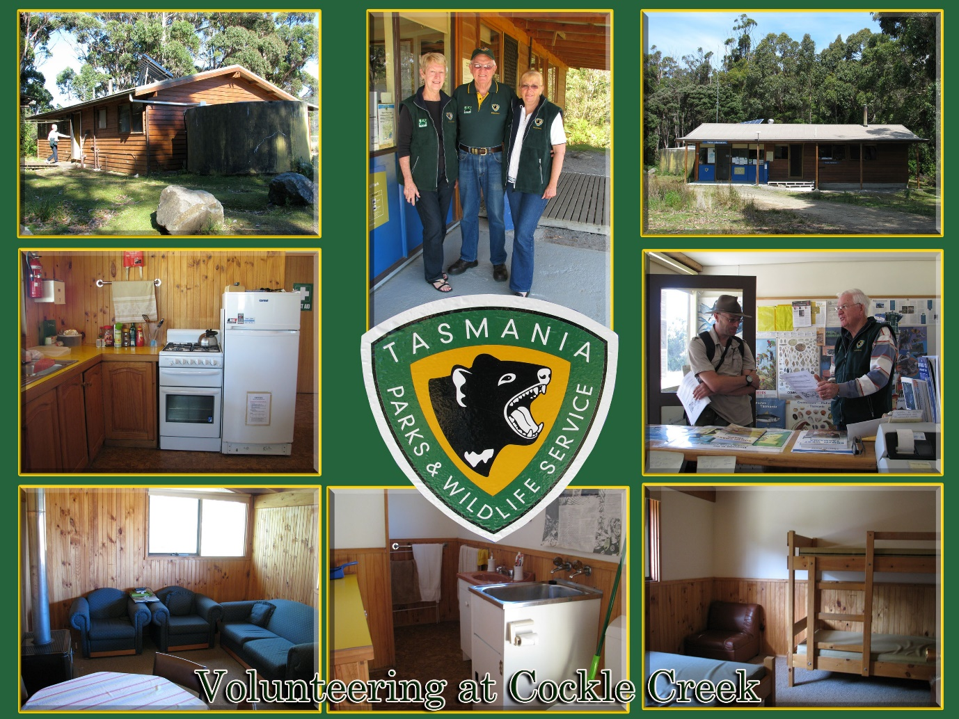
Photos by: Volunteer Caretaker Lorraine Walker
Cockle Creek Volunteer Caretaker Application Form

(Complete one form for each volunteer

Contact Details

Name (volunteer 1):__________________________________________________________

Address____________________________________________________________________

___________________________________________________________________________

Phone: Home_______________________
Work _______________________
Mobile ______________________

Email: _________________________________________________________

Age last birthday: _________________

WILDCARE 2018 membership number: _______________________________

Name (volunteer 2): _________________________________________________________

Address:____________________________________________________________________

___________________________________________________________________________

Phone: Home_______________________
Work _______________________
Mobile ______________________

Email: ___________________________________________________________

Age last birthday: ____________________________

WILDCARE 20016 membership number: ________________________________

Include any other contact details so that we can reach you in 2018 - 19 holiday period.
___________________________________________________________________________As above:

Other:
___________________________________________________________________________

Preferred Placement Dates (pls order by number 1 -5 )

Indicate any months that you are not available
NB: Placements will run from Mid-month to Mid-Month

December

January

February

March

April

Notes: Mention anything relevant to placements here

Addressing the Selection Criteria

- Provide a brief summary of your experience living and/or working in remote locations.

- Provide evidence of your ability to communicate with the broad range of visitors
Expected at Cockle Creek.

- Provide evidence of your knowledge of the general principles of reserved land management, in particular the Southwest National Park, Southwest Conservation Area and Recherche Bay Nature Recreation Area.

- Describe any practical / educational skills appropriate to general outdoor tasks at Cockle
Creek

- Ability to work in a team and take direction from the Ranger

Signed 1. __________________________________ Date _________________

Signed 2 __________________________________ Date _________________

Forward all completed applications to:

Pip Gowen
Regional Volunteer Facilitator South
Parks and Wildlife Service

E: pip.gowen@parks.tas.gov.au

By Monday 22 October 2018 (9am)

Applicants will be notified if they have been successful by Friday 26 October 2018

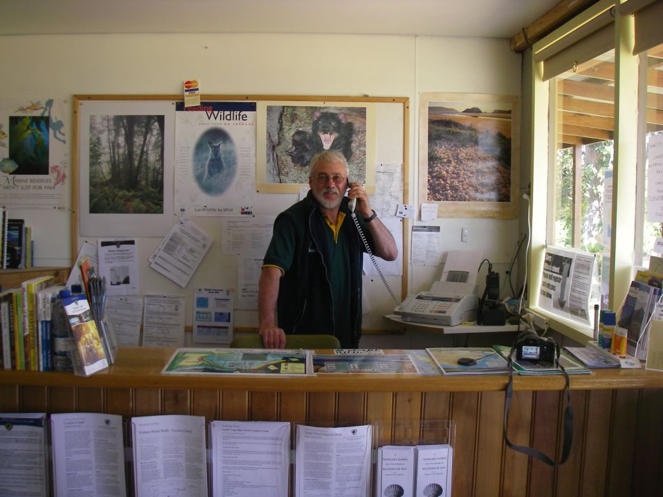
Photo Pip Gowen of Bruce Frankcombe Volunteer Caretaker at Cockle Creek Visitor Office

