CHAUNCY VALE WILDCARE

Chauncy Vale Wildlife Sanctuary (Conservation Area)
Volunteer Caretaker Program 2019
APPLICATION AND INFORMATION
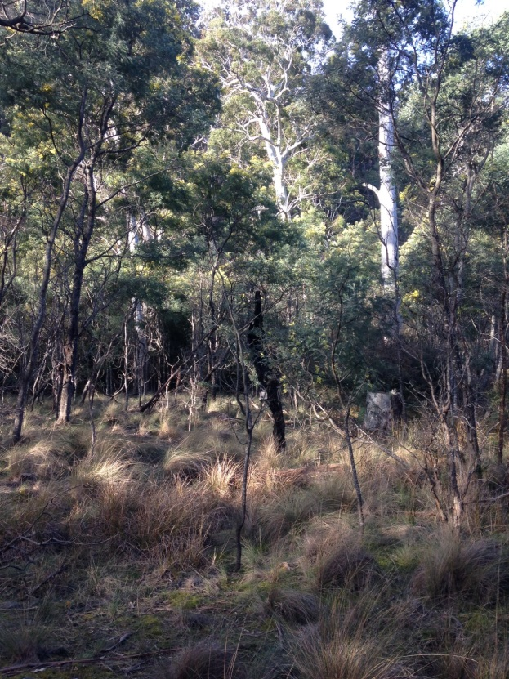
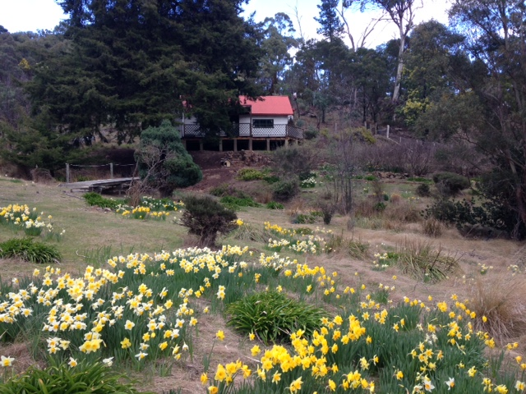

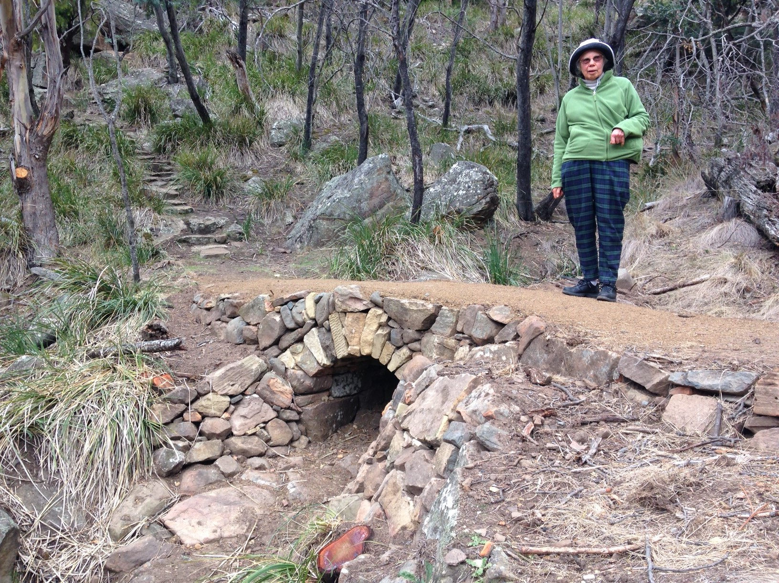

CONTENTS

INTRODUCTION 3
ABOUT THIS PROGRAM 4
VOLUNTEER CARETAKER DUTIES 4
ACCOMMODATION 5
PROGRAM DATES 6
SELECTION CONSIDERATIONS 7
Closing dates and acknowledgement 7
Further Information 8
Contact Details 8
APPLICATION FORM – VOLUNTEER TEAM 9
APPLICATION FORM – INDIVIDUAL VOLUNTEERS 12
Submission of application 13

INTRODUCTION

Chauncy Vale Wildlife Sanctuary, established in 1946 by Nan and Anton Chauncy, is one of the oldest private Conservation Areas in Tasmania. This program is about establishing a roster of volunteers for periods of up to two months primarily to be a point of contact for visitors and to assist in day to day functions of running the Chauncy Vale visitor precinct. Recently renovated, clean, self-contained accommodation is available on site for the use of volunteer caretakers.
The 400 hectare Chauncy Vale Wildlife Sanctuary features grassy woodlands, sandstone escarpments, caves, rich native bird diversity, and unique cultural heritage. At just 40 km from Hobart the reserve is accessible and frequented by bushwalkers, field naturalists, bird watchers, historians and family groups.
Chauncy Vale has picnic facilities, a community meeting room, a selection of walking tracks catering for a range of user preferences, and the unique Day Dawn Cottage museum. Formed tracks lead to points of interest such as Brown’s Caves, Brown's Caves Creek, Guvy's Lagoon and Flat Rock lookout points. Chauncy Vale is also available for use by a limited number of campervans.
Many visitors to Chauncy Vale come specifically to view Day Dawn Cottage which was the home of renowned children's author, Nan Chauncy (1900-1970) and her family. The cottage was built between 1916 - 1918 and now provides an insight into a basic, low impact way of living that is now uncommon. The cottage remains set up as used by the Chauncys in the 1960's and is available for viewing by appointment.
Chauncy Vale is managed by the Chauncy Vale Management Committee comprising representatives from Southern Midlands Council, Parks and Wildlife Service, Tasmanian Land Conservancy and the community.

ABOUT THIS PROGRAM

This program seeks volunteer caretakers for at least 1 month placement blocks. Caretakers are expected to maintain a regular presence in the reserve for the duration of their placement.

Volunteer caretakers live onsite primarily providing a support service to visitors and work with the Southern Midlands Council’s Reserve Manager to assist in the running of the visitor precinct.

The volunteer caretaking role is ideally suited to:
- Wildcare volunteers who have experience contributing to programs in Tasmania’s reserves;
- Retirees;
- ‘Artist in residence’ or similar i.e. people able to undertake part time work on site whilst accommodating the caretaker duties.

The caretaker role can be undertaken by an individual, a couple, a family, or other small team of people. The team need to know each other well enough to live and undertake caretaker duties together effectively.

VOLUNTEER CARETAKER DUTIES

Volunteer caretaker duties include:
- Be a point of contact to provide visitor information about the reserve.
- Lock the gate each night, and unlock the gate each morning. Keep the gate locked on days of total fire ban (and put up a notice).
- Day Dawn Cottage: periodically open the cottage for visitors; keep the cottage clean; collect entry fees; sell books and cards.
- Keep picnic areas tidy and swap BBQ gas bottles on a needs basis.
- Ensure toilets have enough toilet paper.
- Report any maintenance concerns to the reserve manager to ensure facilities are kept clean and serviceable. Notify the reserve manager of any issues that require addressing.
- Report any issues of concern regarding noise, rubbish, vandalism, fires, or firewood theft to the reserve manager.
- Provide a point of contact in event of a visitor’s medical emergency in the reserve.
- Maintain the caretaker’s residence in a clean and tidy condition.
- Coordinate the disposal of rubbish from the reserve through appropriate council staff.
- Conduct all duties and activities in accordance with the Southern Midlands Council Code of Conduct and Occupational Health and Safety policies and procedures.
- Provide feedback to the reserve manager at the end of a placement.
Volunteer caretaker induction/training will be provided on site.

Volunteer caretakers will not be required to:
- Be involved in any law enforcement activities, or confront visitors over any such issues, unless there is an immediate risk to personal safety.

Chauncy Vale Wildcare & Southern Midlands Council will provide:
- Accommodation at the 3 bedroom furnished Caretaker’s residence.
- Onsite induction and safety briefing.
- Information folders - both operational and for visitor information.
- Support by phone and in person as needed.
- First aid kits.
- Items of clothing to identify Volunteer Caretakers.

Volunteer caretaker’s will be expected to provide:
- All food and consumables for the duration of their placement.
- All bedding and linen (consider mattress protector & electric blanket).
- All clothing apart from supplied uniform items (see above).
- Sturdy work boots.
- Work clothing or overalls.
- Own vehicle.
- Relevant medical information and emergency contact details.

ACCOMMODATION

Volunteer Caretakers will be accommodated in the Caretaker’s residence within the reserve. The residence has the following features:
- well-appointed modern kitchen including utensils, cutlery and crockery;
- wood heater and heat pump in the kitchen/dining area;
- 3 bedrooms;
- bathroom and laundry;
- satellite NBN;
- outdoor living options (spacious deck); and
- undercover parking close to the residence.

The Volunteer Caretakers will have sole occupancy of the residence. On occasion reserve management staff and committee may visit site during your placement, and may require access to the kitchen and other facilities.

Firewood is by Council staff
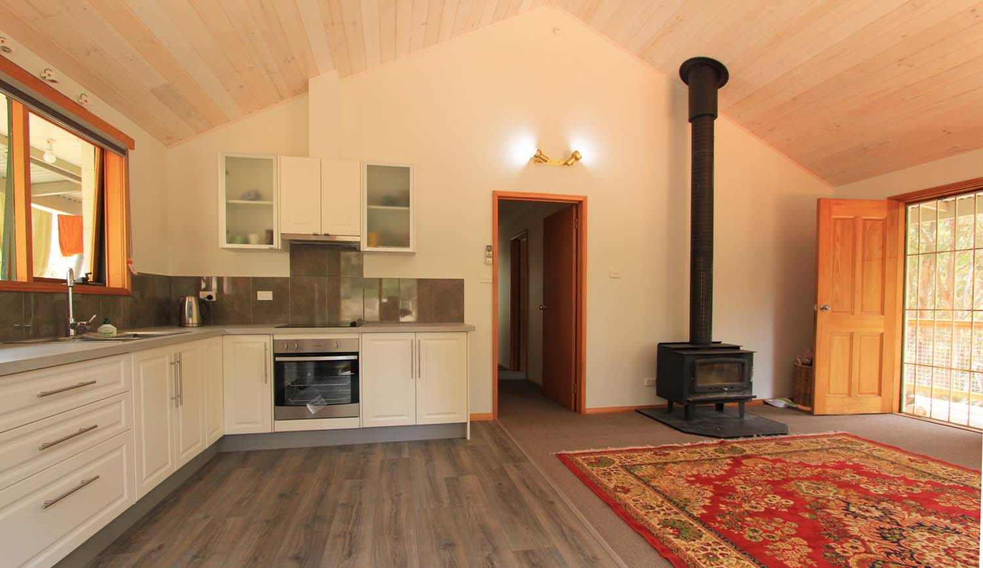

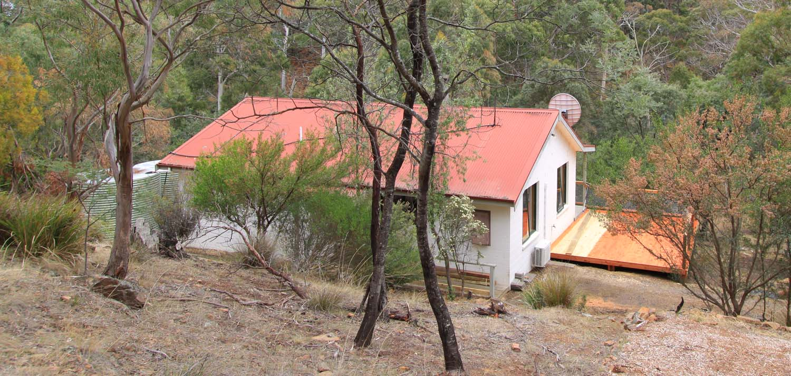

PROGRAM DATES

In this call for Expressions of Interest we are looking for interested persons for placements throughout 2019.

SELECTION CONSIDERATIONS

Volunteer Caretakers will require an ability to live semi-remotely in a natural bush setting. This is a predominantly ‘people focused’ volunteering position, so a friendly, personable and at times tolerant attitude is important.
It is also important to have a sound general knowledge of the reserve, and reasonable practical skills.

Volunteer Caretakers will be selected according to how well they meet the following selection considerations:
- Ability to live and work in a semi-remote quiet bush setting for up to two months.
- Ability to advise visitors on the recreational opportunities, features, and risks (e.g. snakes) in the reserve.
- Ability to communicate well with a broad range of visitors, including those who may have different cultural values to their own.
- Willingness to effectively interpret, and guide visitor groups through, Day Dawn Cottage museum.
- Ability to work in effective collaboration and communication with the Reserve Management team, in terms of managing group bookings and keeping the visitor precinct tidy and functional.
- Knowledge of the cultural and natural history of Chauncy Vale Wildlife Sanctuary.
- Practical skills appropriate to undertake routine maintenance tasks, such as cutting/moving fallen tree limbs from tracks, if necessary.
- First aid or medical qualification highly desirable for at least one member of each team.

Closing dates and acknowledgement

Expressions of interest for 2019 placements can be lodged at any time but no later than the advised closing dates below:
Placement period | Closing date for EOI
January - March 2019 | November 30th 2018
April - June 2019 | February 28th 2019
July – September 2019 | May 31st 2019
October – December 2019 | August 31st 2019

Thank you for your interest.
All applications will be acknowledged and applicants advised of the outcome of their application within two weeks of the closing dates.

Further Information

Site Induction and Volunteer Changeover
Southern Midlands Council will conduct an induction and safety briefing for caretakers on site on the first day of placement. This briefing is ideally conducted as a farewell and thank you to outgoing the Caretakers as well, so there can be an opportunity for an exchange of information from one team to the next.

Work Health and Safety
Southern Midlands Council values the safety and well-being of employees, volunteers and others with whom we have a relationship in our places of work.
The provision of a safe working environment and safe working procedures is mandatory for all works carried out by Southern Midlands Council. The Volunteer program at Chauncy Vale is run according to all current safe-working guidelines. Volunteers will be made familiar with these procedures during the Induction at the start of a placement.

Contact Details

Graham Green
Chauncy Vale Reserve Management
Southern Midlands Council
85 Main Street Kempton, Tas 7030
Mobile: 0422 936027
Email: ggreen@southernmidlands.tas.gov.au
https://www.southernmidlands.tas.gov.au/chauncy-vale/
www.wildcaretas.org.au

APPLICATION FORM – VOLUNTEER TEAM

Please complete the information on this page for your volunteer team. Each person in the volunteer team must also complete the Application Form – Individual.

VOLUNTEER NAMES:
Given Name | Surname
1.
2.
3.
4.

PREFERRED PLACEMENT BLOCKS
Please note – Applicants available for at least 2 months will be prioritised.
Placement | Please mark ‘yes’ in the appropriate cell(s)
January ‘19
February ‘19
March ‘19
April ‘19
May ‘19
June ’19
July ‘19
August ’19
September ‘19
October ’19
November ‘19
December ‘19

PLEASE PROVIDE ANSWERS TO EACH OF THE FOLLOWING QUESTIONS:
Please complete the information on this page for your volunteer team. Each person in the volunteer team must also complete the Application Form – Individual.
1. Describe why you/your team is interested in the volunteer caretaker role at Chauncy Vale.

2. Outline any experiences, skills or qualifications that you/your team have that make you suitable for this role.

3. Provide an outline of your/your team’s experience or ability to communicate with groups of people from different backgrounds, particularly in relation to being able to promote and/or interpret the natural and cultural features of Chauncy Vale to visitors.

4. Please describe any practical skills and/or basic maintenance skills that you/your team have that may be useful in this role?

5. Please provide an example of your experience working in a team situation with other volunteers and ability to work effectively with staff responsible for reserve management?

APPLICATION FORM – INDIVIDUAL VOLUNTEERS
Please complete the information on this page for each volunteer in your team.

Surname:
Given name:
Age at last birthday:
Residential address:
Phone (preferred contact #):
Email:
WILDCARE membership number:
Current first aid certificate? (Y/N) | If YES, expiry date:  (Please provide a copy of current first aid certificate with this application)
Other medical training? (Type, currency)

Relevant skills/qualifications
Referees (people who can comment on your suitability to undertake this volunteer role) | Referee 1 Name:  Phone Number:
Referee 2 Name:

Phone Number:

MEDICAL DISCLOSURE
Applicants selected for the volunteer caretaker program will be asked to provide information giving details of any medical condition that may impact on their capacity to undertake the duties expected or affect the safety of others, and provide emergency contact details. This form must be completed before commencing duties and taken with you to the induction session on day one of the placement. You will not be asked to complete this form if you are unsuccessful in your application.

DISCLAIMER
By completing this form I agree to be available for an induction session at the Chauncy Vale Caretaker’s residence on the day of commencing the placement or at another arranged time.

The Information provided is correct to the best of my knowledge:

Signed Volunteer 1 __________________________________ Date _________________

Signed Volunteer 2 __________________________________ Date _________________

Signed Volunteer 3 __________________________________ Date _________________

Signed Volunteer 4 __________________________________ Date _________________

Submission of application

Please forward your completed application by email to:
Graham Green (Southern Midlands Council)
Email: ggreen@southernmidlands.tas.gov.au

