Mount Field
Volunteer Caretaker Program 2017-18

INFORMATION AND APPLICATION FORM
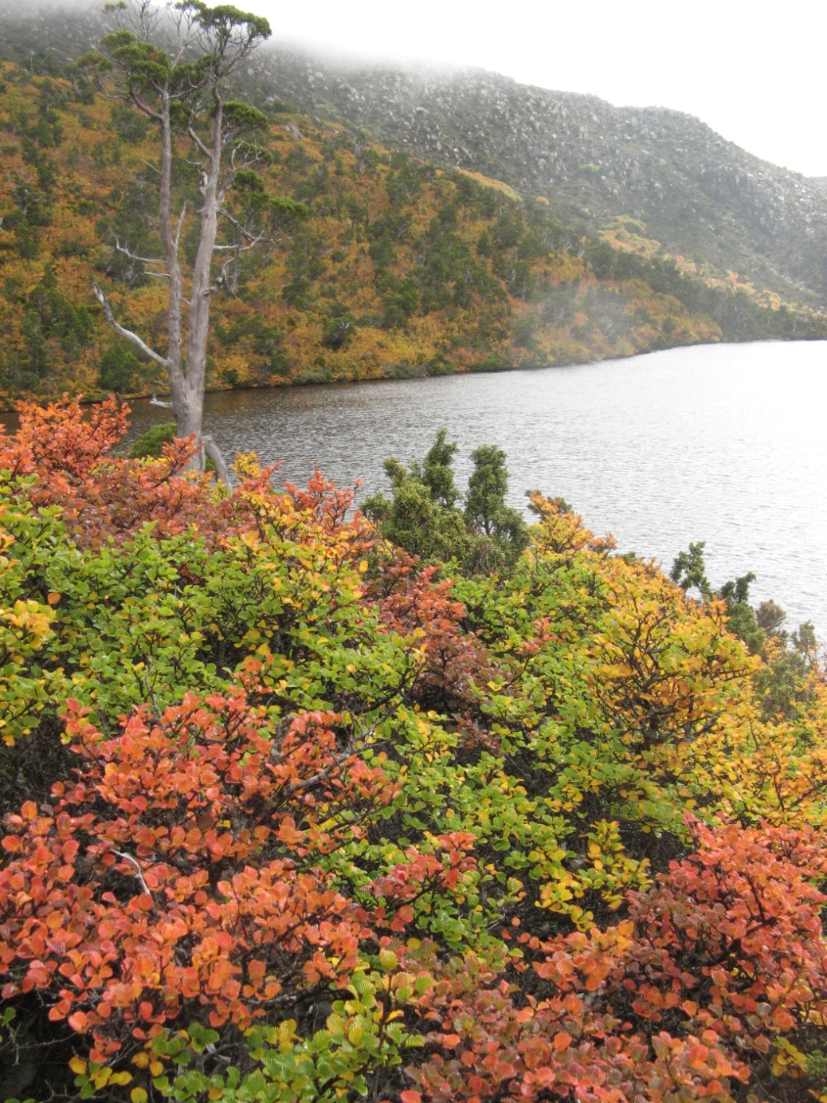

Introduction
The Mt Field Volunteer Caretaker Program provides opportunities for volunteers to enjoy living and to volunteer in the World Heritage Area listed Mt Field National Park.

Volunteer Caretakers will provide a physical presence, provide visitor information about the natural history of the area, carry out minor maintenance and assist with coordination of other Parks and Wildlife Services (PWS) activities at the site. There may also be an opportunity to join the Friends of Mt Field volunteer group in one of their monthly working bees, held on the third Saturday of each month.

During the week caretakers will have time to read/write, walk and fish and to explore Mt Field’s many attractions. These include waterfalls, tall trees, alpine areas, glacial lakes, rainforest and the many species of wildlife that abound in the area.

The opportunity to volunteer at Mt Field may serve as an ‘apprenticeship’ for those people seeking volunteer positions at other PWS locations.

About Mt Field National Park
Mount Field National Park
Mt Field is one of Tasmania's most diverse national parks. From the tall forests at the base of the mountain to the unique alpine plants at its summit, this national park offers the visitor an array of natural wonders. The wheelchair grade walk to Russell Falls is the most popular track in the park. Through a forest of towering tree ferns, this level path will take you to the beautiful Russell Falls. For many people, this three-tier waterfall is the prettiest in Tasmania. Don't miss it.
The winding road that leads to the higher slopes of the mountain passes through an ever-changing succession of plant communities. Interestingly, Mt Field is unusual in that plant diversity increases with altitude. The Pandani Grove walk around Lake Dobson is the perfect place to discover some of the park's bizarre alpine species. With patience, and a little luck, you may even see a platypus in the lake. Early morning and late evenings are the best times to be on the lookout.
For Hobart residents, Mt Field is a close and well-loved skiing venue. Often during the winter months, tows operate on the slopes on most weekends, however, since there is no guarantee that they will be operating (snow lie is variable) it is best to check the Southern Tasmanian Ski Association web site, at http://stsa.webbed.com.au/ or phone 6288 1166. Down-hill, snowboarding and cross country skiing are popular. From the ski huts, a well-marked track leads you to the spectacular Tarn Shelf, a stunning, lake-ridden shelf that was carved out by the force of glaciers from the previous Ice Age. During autumn, the slopes of the mountains which back onto Tarn Shelf and along the shores of Lake Fenton become a riot of colour as the fagus, or deciduous beech, turns gold and red and orange.
Among the many natural heritage values to be found within the park are:
- 13 plant species recorded as rare in Tasmania;
- a swamp gum (Eucalyptus regnans) and stringybark (E. obliqua) wet forest community that is also of outstanding display value;
- easily seen eastern barred bandicoots (Perameles gunnii), a mammal listed nationally as vulnerable;
- complex karst features of high geoconservation value;
- outstanding glacial features such as K Col and the Lake Fenton blockstream;
- at least four invertebrates that are listed as either rare, threatened or vulnerable at the State level;
- wet sclerophyll forest communities of high conservation value;
- alpine and subalpine communities of high conservation value; and
- the Lake Fenton / Lady Barron Creek drinking water catchment which provides 20% of the domestic water supply for Hobart.
Additionally the park encompasses many cultural heritage values, including:
- Along with Freycinet National Park, Mt Field Nat. Park is Tasmania's oldest national park, which is also one of the oldest reserves in Australia;
- known Aboriginal heritage values;
- an important part in the development of the Derwent valley region; and
- many sites and artefacts of historic cultural heritage significance such as Twilight Tarn hut.

Program Dates and Duration
The program will commence mid December 2017, and extend to approx. Anzac Day, 2018. Length of stay for each volunteer caretaker is at least 4 weeks.
NB Tasmanian Applications Only this season 2017 18

Volunteer Caretaker Duties Will Include
- Meeting and greeting visitors – Being a welcoming front face of PWS – explain the facilities
- Answer visitor questions and redirect them to the Visitor Information Centre for further info
- Carry out minor maintenance of tasks identified in the approved work program
- Reporting issues such safety hazards and bushfire risk to PWS Mt Field staff.
- Other tasks identified and appropriate to the capacity of individual Volunteer Caretakers.

Volunteer Caretakers Will Not Be Required To
- Be involved in any law enforcement activities, or confront visitors over any such issue unless there is an immediate risk to personal safety.

The Parks and Wildlife Service Will Provide
- Induction and Work Health Safety briefing
- Support by phone and in person as needed
- Emergency communications
- First aid kits
- Any tools and equipment necessary for minor maintenance duties
- Items of clothing to identify Volunteer Caretakers (VEST and name badge)
- 2 month Parks Pass

Volunteer Caretakers will be expected to provide
- Own accommodation e.g. motor home, caravan
- All food for the duration of their duty
- All clothing apart from uniform items (see above)
- All bedding and linen
- Transport to and from Mt Field National Park

Accommodation
Volunteer Caretakers will be accommodated in their own transportable accommodation (caravan, motorhome or tent)
- 4G mobile phone coverage is available for the area

Qualifications and Selection Criteria
Volunteer Caretakers will not require specialist or trade qualifications, but general knowledge of the area, communication and practical skills. If, however, you have specialist qualifications that you consider may be useful (eg carpenter, electrician, trades skills) please advise us on the program application form. Special skills in arts and culture are highly regarded and should also be mentioned.

Volunteer Caretakers will be selected according to how well they meet the following selection criteria:
- Ability to live and work in a semi-remote location, with limited ‘home comforts’ for the period of stay
- Ability to communicate well with a broad range of visitors
- Knowledge of, or the ability to rapidly acquire knowledge of the cultural and natural history of Mt Field National Park
- Possessing a broad range of practical skills appropriate to tasks agreed
- First aid qualifications or medical knowledge highly desirable for at least one member of each team

Training
The Parks and Wildlife Service will conduct induction and familiarisation sessions for caretakers on site.

All applicants are encouraged to join WILDCARE.

Work Health and Safety
The provision of a safe working environment and safe working procedures is mandatory for all works carried out by PWS. The Volunteer program at Mount Field National Park will be carried out according to all current safe-working guidelines. Volunteers will be made familiar with these procedures during the Induction and will be expected to adhere to them.

Conditions of Engagement in Volunteer Program
All people volunteering with Parks and Wildlife Service are required to conduct their duties in accordance with the State Service principles and Code of Conduct. Agency expectations will be explained at the Induction.

How to Apply
See attached application form – NB Tasmanian Applications Only this season

Closing Date
…9.00am Monday 2 OCT 2017 ….

Department of Primary Industries
Parks Water and Environment

Mount Field National Park
Volunteer Caretaker Program 2017-18
Tasmanian Applications Only this season

APPLICATION FORM
Each person or couple applying must complete an Application Form
Couples please include comments from each of you in the Selection Criteria

VOLUNTEER 1
Surname Given Name/s

Age last birthday Preferred name

Residential address Postcode

Postal Address (Only if different)

Phone: Home Work Mobile

Email:

WILDCARE 2017 membership number:

VOLUNTEER 2
Surname Given Name/s

Age last birthday Preferred name

Residential address Postcode

Postal Address (Only if different)

Phone: Home Work Mobile

Email:

WILDCARE 2017 membership number:

EMERGENCY CONTACT DETAILS
Name

Address

Phone(s)

PREFERRED SESSION(S) IN 4 WEEK BLOCKS (make selection on last page)

December 2017 – January 2018

January 2018 – February 2018

February 2018 – March 2018

March 2018 - April 2018

TRAINING AND CHANGE OVER
Training will be provided onsite. All Caretakers are required to attend this training. The site induction will include a briefing from the Mt Field Ranger or Pip Gowen (Southern Region Volunteer Facilitator) or another PWS staff member will conduct the training and induction on site.

POLICE CHECK
As are acting as representatives of the PWS it is a requirement that police checks be completed prior to starting. Pip Gowen will provide the form and note that it is for volunteer purposes. This will ensure no cost is incurred.

REFEREES
(only needed for those applying for the first time)
Please provide the details of two people who could comment on your suitability to undertake the type of volunteer activity requested.

Name Contact Details

Name Contact Details

PLEASE ADDRESS EACH OF THE FOLLOWING SELECTION CRITERIA

- Provide a brief outline of why you would enjoy living in a semi-remote location and any experience you have of a similar nature.

- Provide evidence of your ability to communicate with the broad range of visitors expected at Mt Field National Park

- Provide evidence of your knowledge of the cultural and natural heritage of Mount Field National Park

- Describe what practical skills you would be able to apply on site.

- Demonstrate ability to work in a team situation with other volunteers and Parks and Wildlife Staff.

LEVEL 2/SENIOR FIRST AID CERTIFICATE
(desirable but not required)
Please attach a copy of your current Workplace level 2 First Aid Certificate or equivalent with this application if you have the training.

MEDICAL DISCLOSURE
The Department of Primary Industries, Parks, Water and Environment values the safety and well-being of employees, volunteers and others within whom we have a relationship in our places of work. We aim to minimise the risk of injury and ill-health by providing safe workplaces.

To assist the Department in this regard, applicants selected for the program will be sent a Medical Disclosure Form. This form must be completed and returned to the Southern Regional Volunteer Facilitator before commencing duties.

You will not be asked to complete this form if you are unsuccessful in your application.
POLICE CRIMINAL HISTORY
The Parks and Wildlife Service has determined that before taking up appointment the person nominated for this position is able to satisfy a Police Criminal History check for:
- Crimes involving dishonesty (primarily related to handling of public money)
- Crimes of Violence
- Sex related offences
- Serious drug offences

Please note it can take some time to have this form returned from the police so it is recommended you process this as early as possible. This form must be completed and returned to the Southern Region Volunteer Facilitator in sufficient time for the check to be completed prior to commencing duties. The form will not be progressed until the placement period is confirmed.

DISCLAIMER
The Department’s Personal Information protection policy ensures management of personal information is in accordance with the Personal Information Protection Act (2004).

Do you consent to the Department using your personal information for the purposes for which it has been provided and for summarised general reporting on volunteering activities?
Yes No (please circle)

By completing this form I agree to be available for a training session at Quarantine Station on the day of commencing the placement or at another time arranged.

The Information provided is correct to the best of my knowledge:

Signed 1 __________________________________ Date _________________

Signed 2 __________________________________ Date _________________

FORWARD COMPLETED APPLICATION TO:
Pip Gowen
Regional Volunteer Facilitator (South)

Email: pip.gowen@parks.tas.gov.au

Enquiries to: Pip Gowen on M: 0427 648 463

CLOSING DATE: .. 9.00AM MONDAY 2 OCTOBER 2017...

Thank you for your interest.
All applicants will be advised if they have been successful in being selected
BY: FRI 6 OCTOBER 2017.

Please provide your placement preferences on next page

Mt Field Campground Volunteer Caretaker Placement Preferences

Please order 1 – 3 and provide any other restrictions if you have re dates

December 2017 to January 2018

January 2018 to February 2018

February 2018 to March 2018

March 2018 to April 2018

What accommodation will you bring with you?
Campervan
Caravan
Tent
Other

Any Questions
Please call
Pip Gowen - Regional Volunteer Facilitator (South)
M: 0427 648 463

Other info about your availability

men mMens

