**APPLICATION AND INFORMATION**



**South Bruny National Park**

**CAPE BRUNY LIGHT STATION**

**Volunteer Caretaker Program 2017 18**

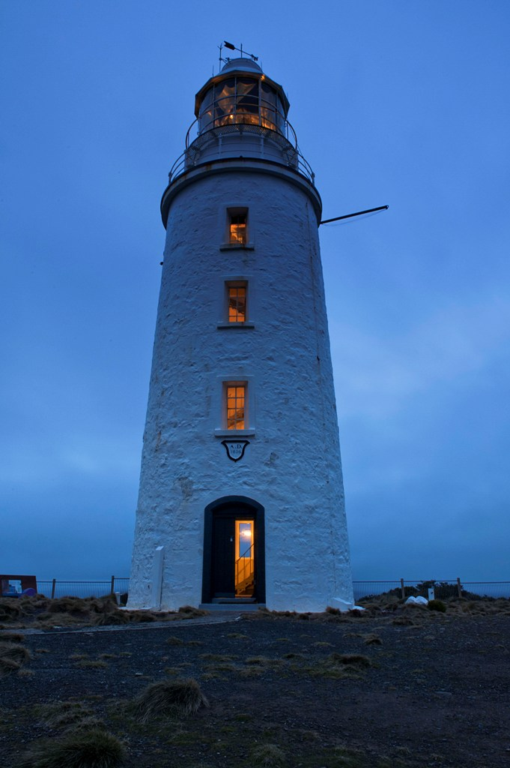

**CONTENTS**

**INTRODUCTION**

**ABOUT THE PROGRAM**

**VOLUNTEER TEAM**

**PROGRAM DATES**

**VOLUNTEER CARETAKER DUTIES**

**WHAT PARKS AND WILDLIFE SERVICE WILL PROVIDE**

**WHAT VOLUNTEERS ARE EXPECTED TO PROVIDE**

**ACCOMODATION**

**INDUCTION**

**TRAINING**

**WORK HEALTH AND SAFETY**

**HOW TO GET INVOLVED**

**QUALIFICATIONS AND SELECTION CRITERIA**

**APPLICATION PROCESS**

**APPLICATION FORM**

**KEY DATES**

**CONTACT DETAILS FOR THE PROGRAM**

**CAPE BRUNY LIGHT STATION**

**VOLUNTEER CARETAKER AND WEATHER OBSERVER PROGRAM**

**December 2017 to September 2018**

**INFORMATION AND APPLICATION FORM**

**INTRODUCTION**

Following a series of mishaps and shipwrecks south of Bruny Island in 1835, Governor George Arthur agreed to erect a lighthouse to guide vessels past Bruny Island. When first lit in March 1838 Cape Bruny was Tasmania’s third lighthouse, and Australia’s fourth. It is now the second oldest lighthouse in the country and the longest continually staffed (158 years). The Cape Bruny light was lit for the last time on 6 August 1996 and replaced by a solar powered light nearby.

Along with most other Tasmanian light stations Cape Bruny was transferred from the Commonwealth Government to the state Government 1 May 1998. In December 2000 it was added to the South Bruny National Park. The lightstation was maintained by a Leasee Caretaker until 2011, when Parks and Wildlife Service Tasmania, established a Volunteer Caretaker and Weather Observer Program.

**ABOUT THIS PROGRAM**

This program now runs year round, in 2 monthly placement blocks. It is generally a 7 day a week role, however from December 2017 to March 2018 there *maybe* 2 groups of Volunteers placed at Station (living in separate quarters), to provide 2 days a week of free time for each group. This is being considered given the significant increase in visitation to Cape Bruny during the spring and summer.

***This new element to the Volunteer Caretaker Placement******is not confirmed yet****.* It may or may not occur, so those interested need to be able to commit to being the only volunteers on this busy site if necessary. I am happy to discuss this with you if you are interested in a placement.

The Volunteer Caretakers live onsite. They provide a welcome and information service to visitors and assist with the running and general maintenance of the site.

The placement includes both Parks and Wildlife Caretaker Roles and a *separate agreement* with Bureau of Metrology (BOM) to complete 2 weather observation each day at 9am and 3pm.

The placement is 2 months so that, in particular, there is time to build up skills to provide accurate weather observations.

**VOLUNTEER TEAM**

**A minimum of 2 adults**

You can put a team together of you and your partner or 2 friends who know each other well enough to live and work remotely together with a busy volunteer role, in potentially adverse weather conditions. Cape Bruny is ideal for a family also.

**PROGRAM DATES**

**In this call for EOI we are looking for interested persons for placements between December 2017 and September 2018**

**Please see break down of the dates in 2 month lots in the Application at end of this document.**

**VOLUNTEER CARETAKER DUTIES will include: (induction/training provided on site)**

* Carry out weather observations for the Bureau of Metrology at 9am and 3pm daily.

(A 2 day training session is provide in Hobart prior to start of volunteer placement)

* Meet and Greet visitors arriving at the Cape Bruny Lightstation precinct. Provide a ‘welcoming face’ of Parks; provide information about site and other opportunities for visitors in the area.
* Ensure the visitor infrastructure incl. public toilet on site is kept clean and serviceable. Also includes the museum, houses and workshops
* Report any malfunction or maintenance concerns to the Ranger as soon as possible
* Provide helpful and professional public face for PWS at Cape Bruny
* Work collaboratively with the commercial operator running lighthouse tours on site
* Provide visitor information regarding services and opportunities available at Cape Bruny, the South Bruny National Park, and Bruny Island as a whole
* Cut grass around the precinct as required to maintain a traditionally neat & tidy appearance
* Maintain the sites power and water supplies through checks of generator and solar systems, water tanks, ensuring any report of issues goes to Ranger as soon as is noticed
* Carry out minor maintenance of building infrastructure, signs and walking tracks as directed by the Ranger
* Maintain small vegetable garden to provide fresh vegetables for yourself and future CT’s
* Carry out litter pick up and coordinate the disposal of rubbish from site through the Rangers
* Monitor visitor numbers and impacts
* Maintain a daily diary noting interesting observations or events
* Liase with the Ranger on day to day operations
* Provide feedback on your departure to Ranger and the Regional Volunteer Facilitator
* Conduct all duties and activities in accordance with the principles of the Tasmanian State Service Code of Conduct and the policies and procedures of the Department of Primary Industries, parks, Water and Environment.

**VOLUNTEER CARETAKERS WILL NOT BE REQUIRED TO:**

* Be involved in any law enforcement activities, or confront visitors over any such issues, unless there is an immediate risk to personal safety.

**THE PARKS AND WILDLIFE SERVICE WILL PROVIDE:**

* Accommodation at one of the ‘Lighthouse keepers Residences;’ (this may need to be shared by PWS staff in event of emergency)
* Onsite Induction and Safety Briefing
* On site Folders with information needed, both operational and information for visitors
* Support by phone and in person as needed
* Emergency communications
* First aid kits, both large in quarters and backpacker kits that can be carried onto the site
* Any Personal Protective Equipment (PPE) tools and equipment necessary for minor maintenance duties and
* Items of clothing to identify Volunteer Caretakers (VEST, hat and name badge)
* Voucher for one return ferry trip Kettering to Bruny Island
* Consumables used in maintaining and cleaning visitor infrastructure
* Firewood as needed and water delivery to site if water tanks run low

**VOLUNTEER CARETAKERS WILL BE EXPECTED TO PROVIDE:**

* All food and consumables for the duration of their placement (suggest fire starters)
* All bedding and linen (consider mattress protector, electric blanket or hot water bottles)
* All clothing apart from uniform items (see above)
* Sturdy work boots
* Old work clothing or overalls
* Own vehicle for transportation to Quarantine Station
* Volunteer Registration/relevant medical information and emergency contact details
* Laptop to record information on the cape Bruny Site Memory Stick
* Additional equipment for internet access as wanted
* Own recreational equipment, bikes, kayaks, hiking boots, entertainment

**ACCOMMODATION**

Volunteer Caretakers will be accommodated in one of the Lighthouse Keepers Residence on site.

* well-appointed kitchen with all utensils, electric hot water, fridge, microwave and stove
* wood fired heater in kitchen/dining area
* 3 bedrooms, 2 with a queen beds and one with two single beds
* another single bed in the room currently used as the BOM weather office
* bathroom with hot shower, hand basin and toilet
* electricity powered by solar with backup from generator
* telephone PWS landline on site OK for limited use and mobile option possible in places
* laundry with washing machine and basin
* parking close to the quarters

The Volunteer Caretakers will have sole occupancy of the Residence, **except in an emergency** where other PWS staff or Emergency Services may need space. On occasion PWS staff will visit site during your placement and when on site require access to the kitchen and other facilities.

The BOM provides a 2 day weather observation training session based in Hobart prior to volunteers commencing on site at Cape Bruny. Volunteers will be provided with a contact and will be responsible for arranging the training directly with BOM

**Qualifications and Selection Criteria**

Volunteer Caretakers will require an ability to live remotely in challenging conditions and to be comfortable being on this high visitation site with a significant number of visitors during the day.

The evenings after sunset are a quieter time on site to enjoy the peace and the natural values of the site. This is a very people focused volunteering position. You do need to like and appreciate the diversity of visitors coming to visit Cape Bruny.

It is also important to have general knowledge of the area, communication skills and practical skills.

See below Selection Criteria to respond to

**SELECTION CRITERIA**

**Volunteer Caretakers will be selected according to how well they meet the following selection criteria:**

* Ability to live and work in a semi-remote location, with limited ‘home comforts’ for 2 months

Including in difficult weather conditions ie windy with potential of changing temperatures

* Ability to communicate well with a broad range of visitors and large number of visitors expected at Cape Bruny (even those who have different cultural values than your own)
* Knowledge of, or the ability to rapidly acquire knowledge of, the cultural and natural history of the South Bruny National Park and heritage of Lighthouse Station
* Practical skills appropriate to undertake routine maintenance tasks, i.e. running of generator, monitoring tank water system, routine cleaning of toilets and grounds etc.
* Ability to take direction from Ranger and yet be flexible if their work schedule means plans need to change

* First aid qualification or medical knowledge highly desirable for at least one member of each team.

**Site Induction and Volunteer Change over**

The Parks and Wildlife Service will conduct an induction and safety briefing for caretakers on site on first day of placement. This is usually conducted as a farewell and thankyou to outgoing Caretakers and welcome to incoming. This facilitates an exchange of relevant current information and also allows for onsite handover of BOM weather observation duties.

All Caretakers are required to attend this induction. Site induction will be conducted by appropriate PWS staff member.

**Work Health and Safety**

The provision of a safe working environment and safe working procedures is mandatory for all works carried out by PWS. The Volunteer program at Cape Bruny will be carried out according to all current safe-working guidelines. Volunteers will be made familiar with these procedures during the Induction or before starting a task using specific equipment, and will be expected to adhere to them.

**Conditions of Engagement in Volunteer Program**

All people volunteering with Parks and Wildlife Service are required to conduct their duties in accordance with the State Service principles and Code of Conduct. Agency expectations will be explained at the Induction.

**How to Apply**

If you are interested in taking part in the Volunteer Caretaker Program, complete the Application Form included with this information package. Please be aware that completion of the application form does not guarantee a place on the program.

**Closing Date**

Applications for the initial placements in the Program will **close on Wednesday 20 September 2017.**

**Selection - notification**

All applications will be considered. Applicants will be notified if they have been successful by Monday 5th September 2016. Please be aware that there continues to be a very high interest in volunteering at Cape Bruny.

My apologies in advance, if there is not enough places for what I know to be very high interest in this Volunteering opportunity.

**Department of Primary Industries Parks Water and Environment**

**South Bruny National Park - Cape Bruny Lightstation**

**Summer Volunteer Caretaker Program 2017/18**

**APPLICATION FORM**

**Each** person of couple/team applying must complete an Application Form

Couples please include comments from each of you in the Selection Criteria

**VOLUNTEER 1**

Surname Given Name/s

Age last birthday Preferred name

Residential address Postcode

Postal Address (Only if different)

Phone: Home Work Mobile

Email:

WILDCARE 2017/18 membership number:

**VOLUNTEER 2**

Surname Given Name/s

Age last birthday Preferred name

Residential address Postcode

Volunteer 2 Cont.

Postal Address (Only if different)

Phone: Home Work Mobile

Email:

WILDCARE 2015/16 membership number:

**EMERGENCY CONTACT DETAILS**

Name Relationship to person

Address

Phone(s)

**PREFERRED SESSION(S) IN 2 month BLOCKS**

Please number 1 – 3 in order of preference or

stipulate a specific session (s) that you are available for.

**Date Start Date Finish Preference 1 - 3**

07 December ‘17 08 February ‘18

08 February ’18 05 April ‘18

05 April ’18 07 June ‘18

07 June ’18 02 August ‘18

02 August ’18 04 October ‘18

04 October ’18 06 December ‘18

**REFEREES**

Please provide the details of two people who could comment on your suitability to undertake the type of volunteer activity requested.

Name Contact Details

Name Contact Details

**PLEASE ADDRESS EACH OF THE FOLLOWING SELECTION CRITERIA**

1. Provide a brief outline of why you would enjoy living in a semi-remote location and any experience you have of a similar nature, especially dealing with: challenging weather; and comfort in being away from entertainment/shops etc.

2. Provide evidence of your ability to communicate with the large numbers of people and broad range of visitors (variety of cultures) expected at Cape Bruny and a little on how you will manage the rather large task of meetings and greeting a significant number of visitors each day.

3. Please tell us what it is you enjoy / know about the cultural and natural heritage of the

Both the Cape Bruny Lightstation and the South Bruny National Park

4. Describe what practical skills you would be able to apply on site. (Include details of any current trade tickets.) This might include, education, filming, interpretation, in addition to practical maintenance skills etc.

5. Demonstrate ability to work in a team situation with other volunteers and take direction from staff responsible for management of the area .

**LEVEL 2/SENIOR FIRST AID CERTIFICATE**

(Desirable – required by at least one volunteer of your team)

Do you hold a current First Aid Certificate? YES/NO Expiry Date

If yes, please attach a copy of your current Workplace level 2 First Aid Certificate or equivalent with this application.

**MEDICAL DISCLOSURE**

The Department of Primary Industries, Parks, Water and Environment values the safety and well-being of employees, volunteers and others with whom we have a relationship in our places of work. We aim to minimise the risk of injury and ill-health by providing safe workplaces. We aim to send everyone home safely.

To assist the Department in this regard, applicants selected for the program will be asked to provide information giving details of any medical condition that may impact on their capacity to undertake the duties expected or affect the safety of others. This form must be completed before commencing duties and taken with you to the induction session at the Station. You will not be asked to complete this form if you are unsuccessful in your application.

**DISCLAIMER**

The Department’s Personal Information protection policy ensures management of personal information is in accordance with the Personal Information Protection Act (2004).

Do you consent to the Department using your personal information for the purposes for which it has been provided and for summarised general reporting on volunteering activities?

Yes No (please circle)

By completing this form I agree to be available for an induction session at Cape Bruny on the day of commencing the placement or at another time arranged.

The Information provided is correct to the best of my knowledge:

Signed 1 __________________________________ Date _________________

Signed 2 __________________________________ Date _________________

**FORWARD COMPLETED APPLICATION by email TO:**

Parks and Wildlife Service Regional Volunteer Facilitator (South) Pip Gowen

E: [pip.gowen@parks.tas.gov.au](mailto:pip.gowen@parks.tas.gov.au)

**CLOSING DATE:** Wednesday 20 September 2017 . Thank you for your interest.

All applications will be acknowledged and applicants advised of the outcome of their application by Monday 25 September 2017

Regards

**Pip Gowen**

**Regional Volunteer Facilitator (South)**

Tasmania Parks and Wildlife Service

1-3, Murrayfield Court, Glenorchy Tas 7010

GPO Box 126 Moonah TAS 7010

General Enquiries: 1300 TASPARKS (1300 827 727)

Mobile: 0427 648463

Email: [pip.gowen@parks.tas.gov.au](mailto:pip.gowen@parks.tas.gov.au)

[www.parks.tas.gov.au](http://www.parks.tas.gov.au)

[www.wildcaretas.org.au](http://www.wildcaretas.org.au)

**[cid:image009.png@01CF1127.F9AB8D00](http://www.youtube.com/PWSTasmania)**   **[cid:image010.gif@01CF1127.F9AB8D00](http://www.facebook.com/pages/Tasmania-Parks-and-Wildlife-Service/147512044296)**    **[cid:image011.png@01CF1127.F9AB8D00](http://twitter.com/#!/@TasmaniaParks)**

        [](http://www.parks.tas.gov.au/index.aspx?base=24210)