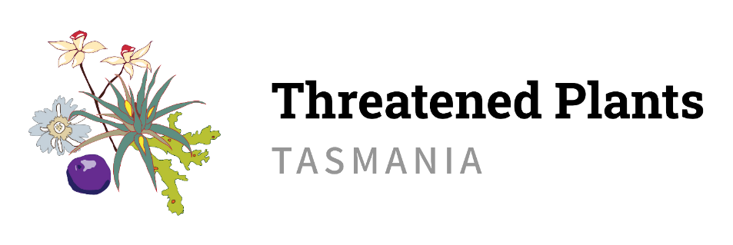

COVID-19 Safety Plan
Threatened Plants Tasmania (TPT) is committed to the health and wellbeing of its volunteers. To minimise the risks of COVID-19 associated with TPT activities the following measures will be applied.

Volunteers are not to attend a TPT event if any of the following apply:
- They have flu-like symptoms including fever, coughing, sore throat, fatigue and shortness of breath.
- They have been diagnosed with COVID-19 OR had contact with someone who has in the last 14 days OR tested for COVID-19 but not received their results.
- They are currently required by Public Health to quarantine or self-isolate.

Good hygiene practices will be encouraged:
- Regular hand washing or use of an alcohol sanitiser (TPT to provide hand sanitiser to be used at the start of field trips & as required).
- Do not use handshaking as a greeting.
- Cover coughs and sneezes.
- Avoid sharing tools and equipment (e.g. GPS, clipboard) unless appropriate hygiene measures have been applied (disinfect between different users – TPT to provide alcohol wipes). In most instances, field trip coordination should ensure minimal need for sharing of tools and equipment.
- Hi-Viz Vests will be washed after each use and all equipment will be disinfected before reuse.

Volunteers to maintain 1.5 m distance between themselves and others during TPT activities. Current gathering sizes and density limits will be reviewed prior to a TPT activity to ensure compliance.

Shared transport/car pooling will not be encouraged by TPT.

Overnight accommodation will not be organised/coordinated by TPT. Volunteers may organise their own personal accommodation if required.

Field trip attendance lists are kept for each field trip that will assist with contact tracing.

TPT meetings should be held virtually or by phone where possible (TPT has a zoom account). Where meetings occur in person, physical distance must be maintained along with current gathering sizes and density limits.

Instruction, training and supervision of volunteers:
- TPTs field trip proforma communicates to volunteers the COVID-19 safety precautions to be applied for the field trip.
- COVID-19 control measures will be included as part of TPTs field trip hazard form. These measures will be verbally explained to volunteers at the safety briefing at the start of each field trip. Field trip participants signature on the attendance list acknowledges their acceptance of these control measures.
- Covid-19 Safety Plan Induction must be completed by all volunteers prior to participation in a DPIPWE field trip (the TPT field trip coordinator will inform volunteers of this requirement for the relevant field trips). Information and training is available at https://dpipwe.tas.gov.au/about-the-department/volunteering-at-dpipwe/volunteer-information-and-training-covid-19

