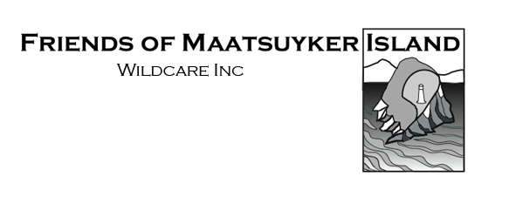

Nomination for Committee 2019-2020
Name of person being nominated for Committee (Nominee)*:
Address:
Contact Phone:
Email:

Nomination:

Committee member
The Nominee also wishes to be considered for the  following Executive position: |  |  |  |  |  | President
 |  |  |  |  |  | Vice President
 |  |  |  |  |  | Secretary
 |  |  |  |  |  | Treasurer

In completing this nomination, I declare that the Nominee and the person submitting the nomination (NB: these can be the same person) are:
- Financial member(s) of Wildcare Inc.
- Member(s) of the Friends of Maatsuyker Island branch of Wildcare Inc.
- The Nominee is prepared to be bound by the FOMI Terms of Reference (available from the Maatsuyker branch page on the Wildcare website).

Person submitting the nomination*
Name:
Signature: Date:

* Note: You may nominate yourself or nominate another member with their agreement.
Please contact wildcaremaatsuyker@gmail.com if you have any questions.
Nomination forms should be submitted to wildcaremaatsuyker@gmail.com by Friday 20th September 2019.

