FRIENDS OF DEAL ISLAND
Newsletter 33
January 2016
Annual General Meeting Thursday 10 March 2016. Make a note in your diary – 5pm at Derwent Sailing Squadron, for 5.30 meeting, to be followed by dinner about 7pm. An agenda and minutes of the last AGM will be circulated closer to the time.
2015 in review; The past year has seen progress made in both conservation of the natural assets and the historic heritage of the Island. Highlights and a lowlight! are:
- Garden Cove and East Cove are no longer dominated by the two extensive sea spurge infestations which were deemed untreatable in the past. It shows what can be achieved by a few people with a bit of determination, persistence and cooperation!
- Apart from ragwort, all other known target weed infestations are controlled, and the start of a program for its treatment is planned for next working bee.
- Extensions to the wallaby exclusion areas by relocating some lengths of fence have further reduced the damage wallabies have been causing to recovering native vegetation by grazing and moving through these sensitive areas near East Cove. As a result, recovery of the vegetation has accelerated and the slopes are becoming more stable.
- Development of the museum continues with the addition of new reading / information materials (including copies of Trauti Reynold’s journals.)The island’s original signal flags were cleaned and housed appropriately. Further preparation for the repair of skylights and the ceiling in the museum was also made.
- A lowlight: a piece of render has fallen out of the side of the lighthouse tower. We have been long aware that there is urgent need for the repair of the lighthouse tower. It was referred to as a management issue in the 2005 Management Plan (now more than 10 years old.) “Within the next few years the light tower will require painting – a major and expensive task. At present the major need is for routine cyclic maintenance.” This is a major issue which demonstrates that there is now only a fairly small window of opportunity to make the repairs necessary for its preservation. We must lift our bottoms off our hands and get busy!
Supporting Each Other….. An article from Devonport’s Bass Strait Maritime Centre’s latest Newsletter
The building of networks and working relationships between maritime and heritage groups is vital to ensure the message of the importance of preserving our heritage is promoted far and wide. It is also an opportunity to support each other with the sharing of knowledge and resources.
The Bass Strait Maritime Centre has formed a strong bond with the Kent Group Museum, responding positively to a request to share one of the Centre’s interpretation panels, selling the Lighthouse Recipe Book which raises funds for the Museum, having Dallas and Shirley Baker as speakers for our Maritime and Heritage Talks and, more recently, receiving three beautifully written and illustrated journals by Trauti Reynolds which the Centre will store for the Museum.
Trauti and her husband, David, were volunteer caretakers on Deal Island three times for a period of three months each time. During their time on the island, both in caretaking roles and on working bees, Trauti kept a day to day journal which she embellished with photographs and hand drawings. Trauti donated the journals to the Kent Group Museum for visitors to enjoy.
As the journals cannot be left on Deal Island due to environmental reasons, they have been scanned and laminated copies put in the Museum on the island for visitors to enjoy. In addition to storing these valuable journals, the Centre has been given permission to display the journals and they will be featured later in the year.
November 2015 Working Bee
Despite the bad weather which reduced the bee by 4 days, the work planned was completed successfully. Just as Caretakers Rob and Fiona had warned us, the island was very dry. They had recorded just a few points in the first half of their stint.
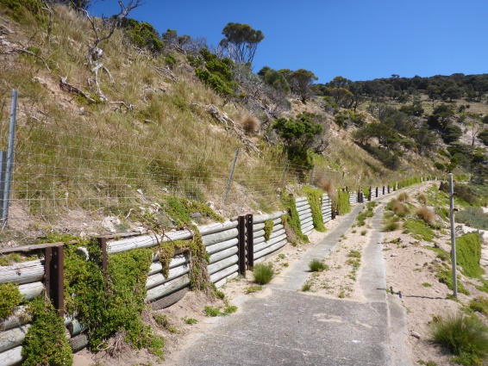
The view of East Cove as we arrived though was encouraging, with many more native grasses growing on the bank, and they were carrying seed, (as our prickly socks indicated). Other native plants too were repopulating those steep and unstable sandy slopes. From arrival, we set out to catch up time, and found that routine maintenance weeding was completed in surprisingly short time. Thistles in the East Cove / Residence Compound area for example, were weeded by the team during the first afternoon. They were fewer and smaller than last time but a few though were flowering, and a small number had seeded.
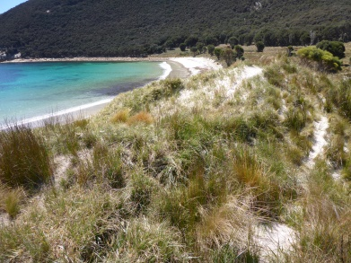
No flowering sea spurge was seen at East Cove, and the regrowth plants were tens of centimetres rather than millimetres apart as they were in April. At Garden Cove spurge was harder to find with between 1500 and 2500 plants removed from the whole 5ha site. We did though find a couple of small seedy outliers which will have to be watched carefully. A few small swarms of two leafed seedlings at several sites were evidence of newly arrived seed brought in by the high water of winter storms.
The main job of this bee was to prepare for the campaign against ragwort which will start in February. (This is the final weed targeted by the current weeding program.) During this bee, the main patches of ragwort infestation were remapped. Markers for permanent transects and photo point monitoring were set up so future progress can be tracked. Likely sites for the release of the bio-control agent, the ragwort flea beetle, which we plan to use to help treat the main patch, were selected. And the majority of the smaller patches were weeded.
Work continued in the museum with the addition of further information, stories and photographic collections to the Reading Room (many prepared off-site). These included copies of Trauti Reynold’s three journals of life on the island. Deal Island’s original signal flags, discovered in a wooden chest under a display case have been cleaned and placed in labelled dust and insect proof containers and fitted back into their allocated pigeonholes in the lighthouse flag cupboard. The larger semaphore flags were placed in a canister on top. A major disappointment though was to find that the interpretation screens, put in place such a short time ago, had become mouldy – and subsequent attempts to clean them had caused further damage to the printed surface. Shirley is following this up with the suppliers.
December General Meeting
A general meeting of the Friends of Deal Island was held at Soho Hotel on 10th December. It was well attended, with 19 members present, and 13 sent their apologies. Despite the interest indicated by this wonderful turn-out, FoDI still lacks a full committee – a situation which has dragged on since the last AGM of FoDI. The lighthouse needs repair urgently – before it is too late. We need more rather than fewer members actively working in a variety of ways to make this happen. The profile of the Deal Island lightstation as being one of Australia’s oldest, most complete and historically, important lightstations, needs to be raised. Dallas has been doing a wonderful job bringing the issue to the attention of politicians including the Tasmanian Minister for Parks and Wildlife, Tasmanian members of the Commonwealth Government, and the Prime Minister.
Reports of the weeding and heritage works done during the November working bee were tabled. Shirley in her capacity as stand in treasurer advised the meeting of our current account balances.
Bob discussed the relationship between FoDI and Parks in conducting natural or cultural heritage works and/ or fund raising for works on Deal (or other lightstations). He also reported a recent discussion with Parks Heritage Officer Peter Rigozzi about possibilities for managing some of this much needed maintenance.
The state government per Parks is responsible for (effectively the owner) of three Tasmanian lighthouses – Bruny, Maatsuyker and Deal Island. Parks is also responsible for the lightstation buildings on Tasman Island, and Low Head including the Pilot Station but in these cases, the lighthouses themselves, as working lights, continue to be owned and maintained by the Australian Government. Parks have allocated some funds to paint the Bruny Is. tower this year, with further funds to do some work on visitor facilities - road upgrading, parking and toilets.
Parks has also allocated a small amount to commence maintenance work on the Maatsuyker lighthouse this year. Friends of Maatsuyker are also contributing some funds and volunteer labour. The work is being guided by a Catch-up Maintenance Plan (the CUMP) which was written as guidance for works on Maatsuyker. Peter Rigozzi has suggested that as the two lantern rooms are very similar, and have similar problems with ingress of water, the Maatsuyker CUMP is also relevant for Deal. Both are Chance bros 1891 12 foot lanterns with diagonal pattern glazing of 16 panels by 3 panes per panel and there are many other features in common too.
Both Peter and the Friends of Maatuyker are agreeable for FoDI to use the same CUMP to guide maintenance work on the Deal Island tower. On Maatsuyker, the work is being led by two experienced contractors and it may be possible to use their services to initiate some of the most urgent work on Deal. Bob to follow this up.
The next working bee is planned to be held from 11th to 29th February.
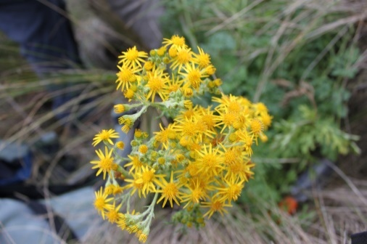
Apart from conducting the program of maintenance weeding of weeds already being treated, this bee will concentrate on the introduction of a population of ragwort flea beetles as bio agents as part of the strategy to control ragwort. It is planned that these little (flea sized) beetles will be collected from the south of the state. They will be vacuumed up as they hatch, transported to Deal and released as quickly as possible to maximise the chance of successful introduction. (This all may even have happened by the time you read this!!!) Meantime, weeding bee’ers will be removing and disposing of as much flowering or seeding material as possible to reduce seed production.
In the museum, it is planned to repair the lathe and plaster ceiling, and the skylight windows.
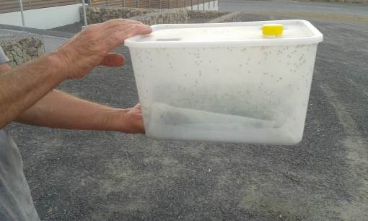
Stop Press 13th January – the Beetles have landed!
Ragwort Flea Beetles have now been installed on Deal Island as biological control agents to be used in the campaign to manage ragwort. Ragwort bio-control expert, Richard Holloway, collected 1200 – 1500 of them from a couple of populations on Bruny Island on Jan. 11th. They travelled by car to Hobart, then to Low Head on the 12th and on to Bridport and early on the 13th. They were flown to Lady Baron, then delivered to Ranger Wayne Dick who promptly delivered them by plane to Deal Island. By the evening of Wednesday January 13th the Caretakers would have introduced them to two sites in the main ragwort patch. With less than three days between capture and release, the beetles have an excellent chance of successful introduction. Just imagine them munching away happily on the island’s lovely lush ragwort.
A Bouquet from the General Manager, Peter Mooney - after visiting Deal Island recently, Peter, in a brief article in the PWS magazine ‘Buttongrass’, commented on the difference that the Friends of Deal Island and the caretakers had made in maintaining the building s of the lightstation, and by removing sea spurge from East Cove.
Dates for your diary Etc…
- Tuesday 2nd February: Maritime Museum Lunchtime Talk. Dallas will be presenting the talk with a PowerPoint presentation about the history and maintenance needs of the Deal Island Lighthouse.
- February working bee; (11th to 29th February 2016) now fully subscribed. (The following bee is likely to be held in November 2016. Put your name down now if you are interested.)
- Friends of Deal Island, AGM and election of committee (you can nominate anytime before or at the meeting), Thursday 10th March at the Derwent Yacht Squadron, Marieville Esplanade, Sandy Bay. Arrive about 5.00 pm to get a refreshment from the bar ready for a 5.30 pm meeting in the DSS Meeting Room, followed by 7pm dinner.
Renew your Wildcare membership: Quick tip - It's a lot easier to renew you Wildcare membership before you renew your Parks and Wildlife Annual Car Pass. If you do, simply quote your Wildcare number and you will receive a discount on your Park Pass. Please be patient – the new Wildcare website is having some teething trouble!
Check that you actually are a member of Friends of Deal Island by logging in to Wildcare Tasmania, selecting the “members”button, then “my preferences”. Here you will find a list of all the groups you have expressed interest in. If Friends of Deal isn’t on your list, use the box provided to “add new group”. Please do check. It saves so much time and effort in getting information out to you if we can use member lists which are complete and up to date. If you wish to withdraw your membership, or do not want to receive news by email, do let us know and we can ‘unsubscribe’ you.
Happy New Year to you, and your families. For Deal Island, may the year 2016 be marked by great strides in the maintenance of both its natural and historic heritage.

Bob and Penny Tyson (President and Editor)

