Friends of Tasman Island
Weeding Report November 2023.
Brett Hall & Martin O’Bryan
Summary
It has been a much drier Winter this year on Tasman Island compared to the previous three years when it has been extremely wet with a ‘La Nina’ weather pattern experienced across Australia. Although drier, the rain that has fallen this Spring has been well timed to maximise grass growth. Indeed, more grass has grown than the previous three years because the soil became so waterlogged that the Spring growth was delayed.
Good news on the Californian Thistle population, where the plants found were sparse and in the immature stage. The numbers continued to decline, with a record low of 220 treated. This continued downward trend means the likelihood of eradicating them from the island is promising.
Not so good were the numbers of Wild Radish and Wild Turnip, with 300 plants removed. Mature plants numbered 148, and seedlings were just ahead with another 152. Three bags of seedheads were removed from the island.
A further surprise was the discovery of more Gladioli down near the pond area. Thanks to Amanda, Annabel & De for helping with the removal of these plants. It’s slow painstaking work that requires careful sifting through the soil to find all the tiny corms and cormlets. We found that each mature plant could have four to ten of these corms underneath them depending on the age of the clump of Gladioli. So, the 220 mature plants had 1,255 corms below the ground.

Weed Name | # Spray Treated | # Pulled | #Dug | Totals
Californian Thistle | 220 | N/A | N/A | 220
Wild Radish/Wild Turnip | 0 | 301 | 0 | 301
Yarrow | 0 | N/A | 27 | 27
Hairy Sedge (Carex hirta) | 2M x 2M (trial) | 0 | 0 | 0
Gladioli | 0 | 220 | 1,255 (corms) | 1,475
Spear Thistle | 0 | 0 | 0 | 0
Docks | 28 | 10 |  | 38
Milk Thistle | 12 | 11 |  | 23
Totals: | 260 | 542 | 1,282 | 2,084

Active Priority Species.
- Californian Thistle/Perennial Thistle/Creeping Thistle (Cirsium arvense.) Declared Weed
https://profiles.ala.org.au/opus/weeds-australia/profile/Cirsium%20arvense
Thistle Zones:
Z1: East of the main track: (Subdivided into four sections, A – Far Eastern, B – East of Q1,
C - Grass pit, D - Opposite Relief Keeper Cottage).
This zone had the largest population at the last working bee in March with 36% (84) of the treated thistles, down to 26% this working bee.
- 35 thistles treated with one site with 20 specimens.
- No thistles found at all, first time that none have been found in any area.
- 14 sparsely spread over the Northern end.
- Seven mature plants in two sites, four under track tree and three in brush beside track.
Z2: North & west of the Relief Keeper Cottage: For many years this zone was the epicentre of the thistle population on Tasman Island with over 70% of the thistle population, now it is down to 20%.
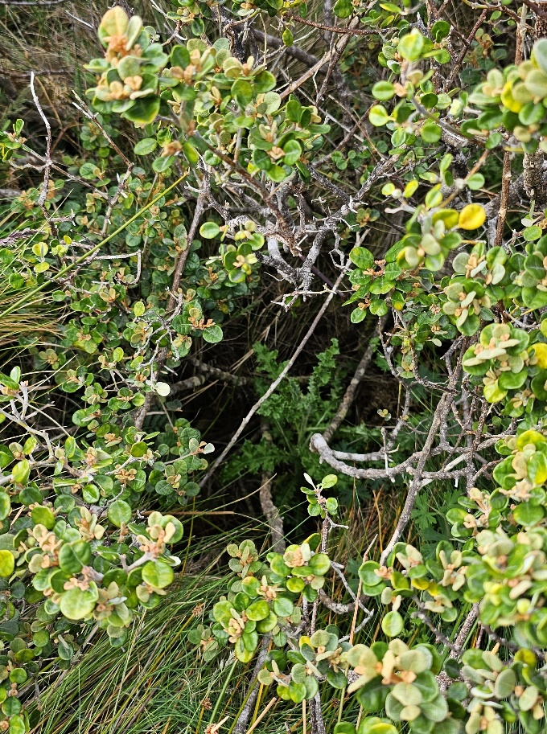

Z3: Middle flat, west of main track: For the last two years this area has had the largest percentage of thistles of all the zones.

Z4: Quarters 1, west & north side: Since the Californian Thistle eradication began in 2018, this is the first time that NO thistles were found inside the garden fence around Quarters one.

Californian Thistle growing under native shrub.

Californian Thistle Treatment:
Zone | Sub section | % Juvenile | % Mature | % Flower | % Seeded | Total Numbers | Total Percent
Z1 | A 35 | 90% | 10%
 | B 0 |  |  |  |  | 0 | 0
 | C 14 | 100%
 | D 7 |  | 100%
Z1 Total | 56 | 80% | 20% |  |  | 56 | 26%
Z2 | 45 | 89% | 11% |  |  | 45 | 20%
Z3 | 89 | 90% | 10% |  |  | 89 | 40%
Z4 | 30 | 100% |  |  |  | 30 | 14%
Totals: | 220 | 86% | 14% | 0% | 0% | 220 | 100%

- Wild Radish (Raphanus raphanistrum L.) Annual, BRASSICACEAE &
Wild Turnip (Brassica rapa L.) ssp. sylvestris (L.) Janch.

https://profiles.ala.org.au/opus/weeds-australia/profile/Raphanus%20raphanistrum

A mixture of both Wild Radish and Turnip were present in the old garden are so we have combined the totals because it is not possible to define the seedlings at such an early stage of development. The majority of the mature plants were Wild Radish, approximately 80%. Considered to be one of Australia's most widespread and serious agricultural weeds. Generally thought to be up to 500mm in height, on Tasman Island they are mostly over 1 metre when mature. An observation was that a lot of unripe seed pods have been removed from the mature plants. We assume it could be birds seeking the seeds which would have a high protein content.

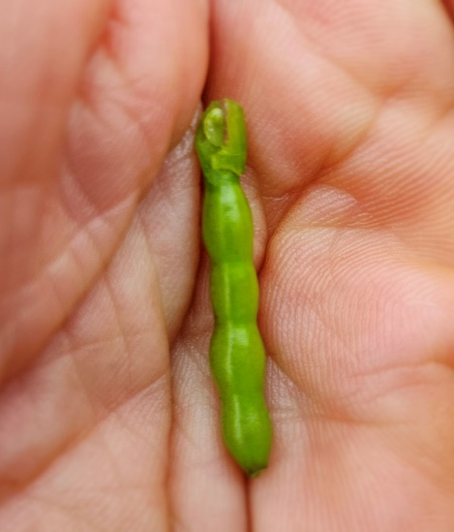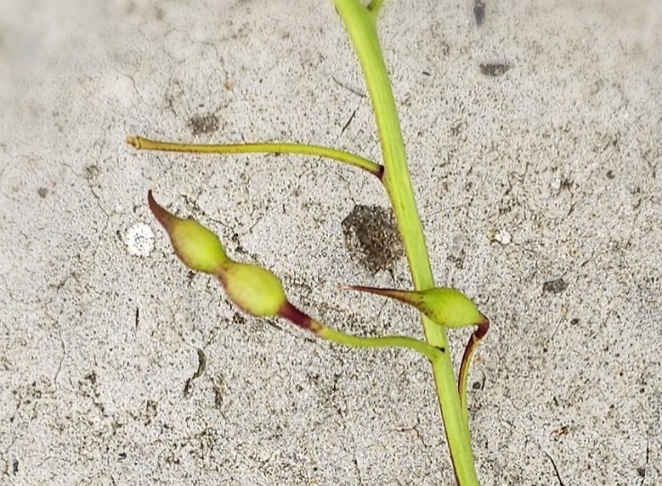

Wild Radish seed pods.
Unripened seed pod.

- (Cont.) Wild Radish (Raphanus raphanistrum L.) Annual, BRASSICACEAE &
Wild Turnip (Brassica rapa L.) ssp. sylvestris (L.) Janch.

Old Garden North of Eastern Track: Ten sites, 117 mature in flower and 94 seedlings.
Old Garden South: Two sites, 31 mature plants in flower and 27 seedlings.
Q2: Previously a Wild Turnip site, nothing identified. Huge volume of grass would have prevented establishment.
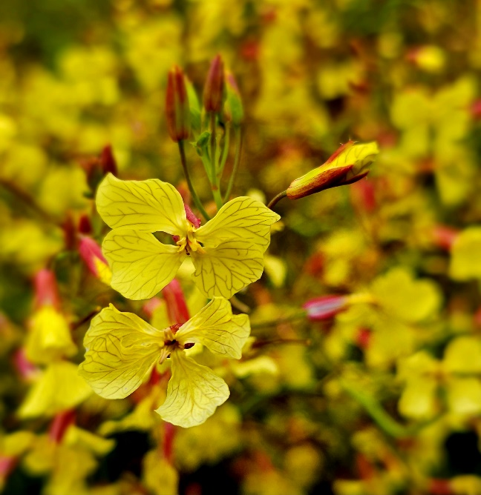

Totals: 12 sites, 148 mature in flower and 152 seedlings.

All stakes removed, repainted white and replaced back at mapped sites.
New seedlings coming through regularly so will need to check all sites during the January working bee.

Wild Radish Flower

- Yarrow (Achillea Millefolium) Family: Asteraceae
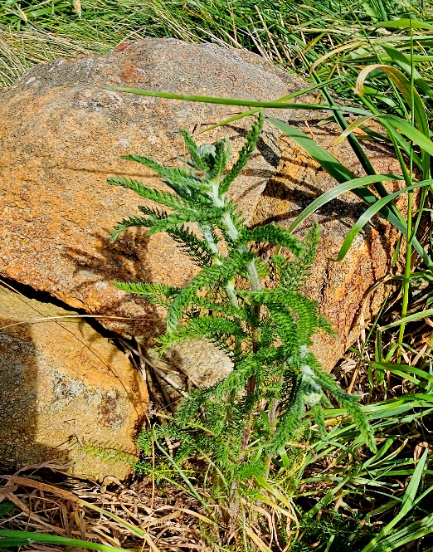
Spring is a key time to eradicate the Yarrow and stop it seeding.
Main Track East: Nothing identified.
Main Track West: Five sites, ten seedlings. All sites identified with white stakes.
Southeast of Q3: Three sites. 1. Inside garden fence, three seedlings. 2. Near stake outside mown area at rock heap, one mature plant with seedhead. 3. Cloer to lighthouse, 13 seedlings.
Totals: Eight sites and 23 seedlings.
Mature Yarrow (Q. 3)
- Gladioli (Gladiolus)
West of Helipad: Two staked sites, two Metres apart. Mature: 31 plants, not fully in flower. Quite difficult to find with the amount of grass present.
Corms: 57.
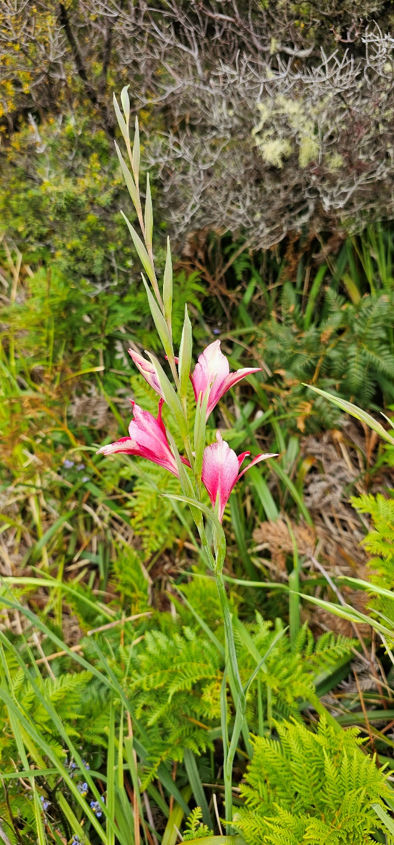
Damsite: One large clump identified (Site 1, 55 mature plants and est. 500 corms) and left in situ to allow the flowers to open more so a photograph can be taken to allow accurate identification. Sample taken for the Hobart Herbarium.
Four days later Annabel identified another six sites further east and southeast of the first location. The other sites appear to not be very old compared to site one, which is the likely source of the other infestations.
Site 2, 21 mature & est. 100 corms.
Site 3, 17 mature & est. 70 corms.
Site 4, 5 mature & 20 corms (actual).
Site 5, 39 mature & 210 corms (actual).
Site 6, 9 mature & 40 corms (actual).
Site 7, 43 mature & 258 corms (actual).
We removed 189 mature plants and 1,198 corms and cormlets altogether from the seven staked sites.

Totals: Nine sites, 220 mature plants coming into flower and 1,255 bulbs/corms. Grand Total 1,475.
Gladioli in flower at Site one, near the dam.

- Hairy Sedge (Carex hirta)
https://en.wikipedia.org/wiki/Carex_hirta
Hairy Sedge or Carex hirta which has characteristic hairy leaves and inflorescences was found on Tasman Island in the low-lying area south of the Relief Keepers Quarters (RKQ) and north of Quarter’s one. This is the first and only record for this species in Tasmania and Australia and is in the early stage of invasion and therefore should be regarded as an eradication target. FoTI considers this weed of high priority for eradication.
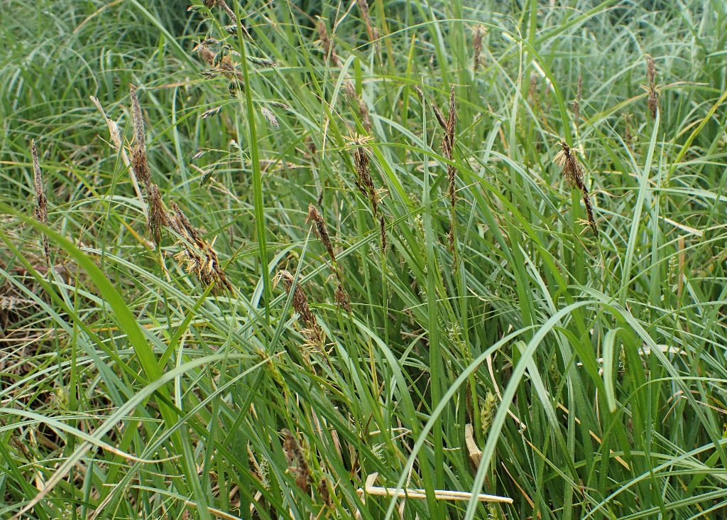
Carex hirta in flower. Pic: Annabel Carle

Hygiene: Annabel Carle in consultation with Chris Creese (FoTI) and Brett Hall (FoTI Weeding leader) at the November working bee, agreed that in future to assist in reducing the unintentional spread of the Carex hirta out of its known area, that the length of track between the ‘No Mow South and No Mow North poles become a No Mow Zone.
A Hairy Sedge/Carex hirta information folder will be available in Q3, this will also include pressed and mounted flowering specimen of Hairy Sedge and is available as reference material for the FoTI Weeders with photographs.

Where is it growing?
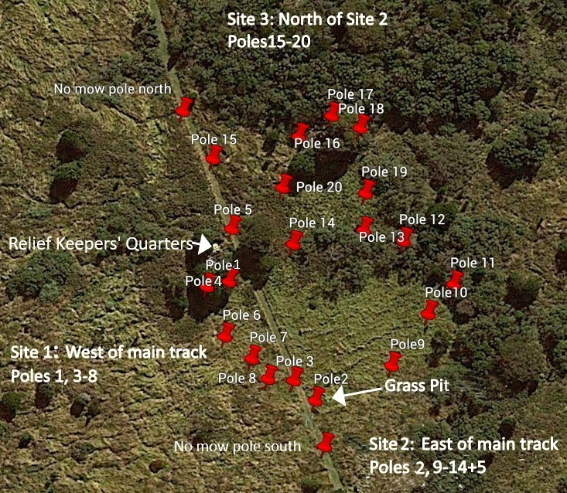
There are three identified Hairy Sedge/Carex hirta sites. FoTI will create exclusion Zones, and no-one will be permitted to enter these three identified Carex hirta sites except authorized FoTI weeders or Parks staff.
Hairy Sedge/Carex hirta boundary pole locations. Map: Annabel Carle

Eradicating Carex hirta – Hairy Sedge
In November 2023, three Carex hirta (Hairy Sedge) sites were identified with a combined area of approx. 2148sqm. The three sites are artificial as the Carex hirta grows connecting via Sites 1 & 2, 1 & 3 and via Sites 2 & 3. The estimated perimeter of the three combined sites on 1 Dec 2023 = 186m.
In the absence of any conclusive published data four trial eradication sites were set up. These each measured 2m x 2m. An extra trial plot could be added in January. Brush-cut then spray with Roundup at 10ml/l. The thick mat of rhizomes of this plant will be difficult to eradicate. We understand that this regime is effective against tougher plants like Juncus pallidus. But it may well need repeat applications.

- Spear Thistle/Scotch Thistle/Black Thistle (Cirsium vulgare)
Quarters 1: Nothing seen here or anywhere else on the island.

Non-Active Priority Species (*Monitored using Fulcrum app).

Arum lily (Zantedeschia aethiopica)
Blackberry (Rubus) Declared Weed *
Northeast sites: None identified.

Fuchsia (Fuchsia magellanica)
Garden pelargonium (Pelargonium Xdomesticum)
Gazania (Gazania linearis)
Hebe (Hebe elliptica)
Mirror Bush (Coprosma repens)
Montbretia (Crocosmia x crocosmiiflora) *
Old dip site: Nothing present.

Old Fashioned Garden Mint, (mentha x. villosa) *
Quarters 1: No sign of any mint and the area was brush cut ready for the next visit.
Scrambling groundsell (Senecio angulatus)
Shasta daisy (Leucanthemum maximum)
Succulents: Tree Aeonium (Aeonium arboreum), Pinwheel (Aeonium haworthii)
and Green Cockscomb (Sedum praealtum)

Parsley (Petroselinum crispum) *
Quarters 1: No Parsley present.
Active Lower Priority Species.
Barley grass (Hordeum murinum) annual
Very little evidence of any Barley Grass.
Docks: Curled dock (Rumex crispus), Broad-leaved dock (Rumex obtusifolius), and Fiddle dock (Rumex pulcher).
Helipad area: Nothing sighted, too much competition from the grass.
Quarters 1: Lots of docks at the rear of the building. 22 treated here and another six elsewhere in the thistle zones. In addition, another ten were pulled.

Garlic (Allium ampeloprasum var. ampeloprasum)
Old Garden: Lower numbers this year with only a few visible through the bracken.
Great brome spear grass (Bromus diandrus.) Introduced annual.
Haulage: Last Summer’s efforts at reducing numbers down the haulage has been effective with no spear grass evident on a walk down there.
Quarters 2 & 3: Light numbers through this area. Check during the January working bee.

Jonquils & Daffodils (Narcissus), Grape hyacinth (Muscari armeniacum) Naked Ladies (Amaryllis belladonna) and Nerines (Amaryllidaceae)
Old Garden north of eastern Track: Few were evident this season and had all died down.
Old Garden south: Few were evident this season and had all died down. Possibly too dry in the early Spring for many to grow.
Four clumps still present in the front garden of Quarters one.
Milk Thistle/ Sow thistle (Sonchus oleraceus)
A fair few Milk Thistles around but most of them had already seeded.
We spray treated 12 thistles and pulled 11 out.

Rough dog’s tail (Cynosurus echinatus) annual
Some along the North end of the main track and at the lower section of the Haulage.

Other Weed Species Present (Widespread & impractical to eliminate)

Common Vetch, (Vicia sativa L.)
Dandelion (Taraxacum officinale)
Fumitory (Fumaria muralis)
Introduced Perennial Grasses: (Cocksfoot, Dactylis glomerata, Ryegrass, Lolium sp
Introduced Annual Grasses: Browntop, Agrostis capillaris L., Yorkshire Fog Grass, Holcus lanatus.
Trifolium (White & Sub clovers)
Huge flower heads and leaves on the White Clover. Very few bees present though.

Chemical Inventory:
Chemical Name: | Batch DOM | Group | Volume | Containers
Lontrel Advanced (Corteva) | C781K6P301 25/6/2020 | I | 4.2L | 1
Kamba M (Nufarm) | 277859-0160 05/18 | I | 250ml | 1
Glyphosate | 42322016 | M | 900ml | 1
Brush-off (DuPont) |  | B | 40g | 1
Pulse (Penetrant & Surfactant) |  |  | 1L & 100ml | 2
Brushwet (Surfactant) |  |  | 200ml
Marking Dye (Red) (Nufarm) | #2202025 02/2022 |  | 1L | 1

Conclusion:
The numbers of Californian Thistles continue to trend downwards. Although it was anticipated that they may have been even lower, as the Spring working bee has always had lower numbers treated than the Autumn working bees. Back in March this year 230 Thistles were treated and 220 were treated this time around. There has been a lot of traffic through the Thistle zones this year (e.g., the ‘Bio Blitz’ in Autumn). People moving through these zones break through the vegetation canopy, which allows the sunlight in, which in turn encourages more thistles to grow. Our Weeders take care to walk in the same footsteps when they transverse the zones to minimise this affect.
Thanks to Annabel Carle for her work in establishing the boundaries of the Hairy Sedge/Carex hirta, setting up the trial sites and providing the written material and photographs about such for this report. Annabel has written a more detailed report specifically about her work on this weed and a copy of that will also be stored with the other weeding material in Quarters three.
Thanks also to Amanda Thompson for assisting with digging out Yarrow and Gladioli plants and keeping an eye out for weeds all over the island whilst looking at flora and fauna.
Several other priority weed type sites will need to be checked in the summer Californian Thistle Weeding Working Bee including, Wild Radish, Gladioli, and the Hairy Sedge/Carex hirta trials.

Recommendations:
- As the number of Californian Thistles gets even lower, we may have to increase our identification of sites (Fulcrum and/or stakes) where treatment has occurred. The ‘Hot Spots’ may have to decrease from a minimum of ten to a minimum of five as an initial step.

- Restrict people accessing the Californian Thistle and Hairy Sedge/Carex hirta sites to people who are monitoring and/or treating these weeds only. This will prevent the further spread of the weeds, maintain the foliage canopy, and make it easier to see what area has been covered during treatment.
- Include Hairy Sedge/Carex hirta on the list of priority weeds for Tasman Island.

- Undertake ongoing trials to determine the best method of controlling/eradicating the Hairy Sedge/Carex hirta. The key times for accurate identification of the Carex hirta (Hairy Sedge) is in Spring when it is in flower or in Summer when the seed has set in the heads. However, it is recommended that the key time for eradication is in Spring before the seed has set. Establish an additional trial site method with firstly brush cutting and then spray with roundup.
- NO mown or brush cut material to be taken outside of the identified Carex hirta sites to prevent further spreading. Grass clippings from around Quarters one can be transported to the existing ‘Grass Disposal Pit’ which is inside the ‘Exclusion Zone’ east of the main track.
- A Carex hirta/Hairy Sedge information/reference folder will be available in Q3 for the FoTI weeders and other Tasman Island visitors. This folder will include written information, a map showing the infested area (as known on 1 December 2023,) photographs of the plant and a pressed and mounted flowering specimen.
- To reduce the risk of unintentional spread of the Carex hirta out of its known area, the length of track between the ‘No Mow South and No Mow North poles become a No Mow Zone. FoTI weeders should regularly monitor for Carex hirta/Hairy Sedge along the full-length of the ditch which runs north from near Q1 to well beyond the Relief Keepers Cottage on the east side of the Track down towards the Haulage.

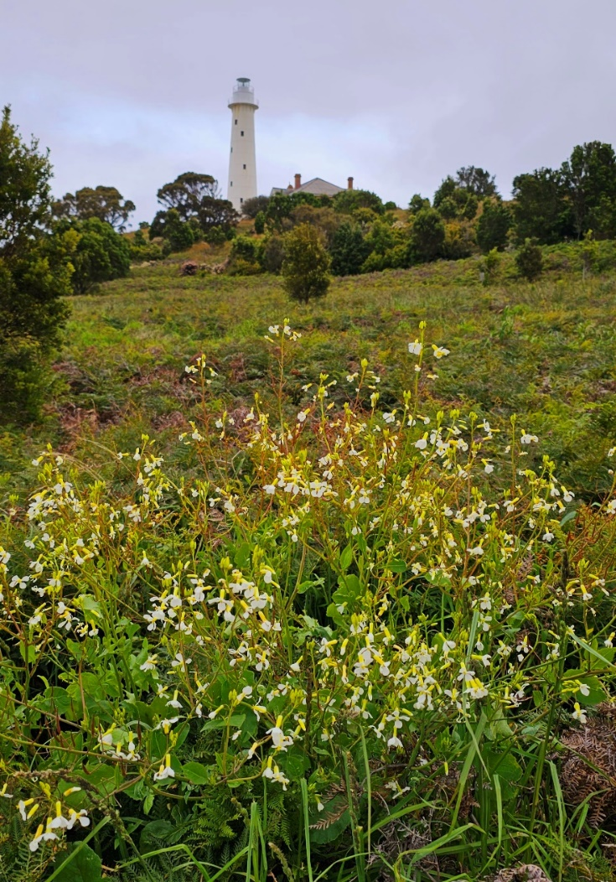
Wild Radish in the Old Garden below Quarters two

All pictures supplied by Brett Hall unless otherwise acknowledged.

