Bruny Island Quarantine Station Newsletter Autumn 2017

A.G.M. s

FOBIQS recently held their AGM, all positions were filled and we welcome David Master to the committee. The committee farewells a long serving and valued member, Jenny Boyer, although Jenny assured us that she will still be able to advise and help when the need arises. Thank you Jenny for your outstanding service to FOBIQS.
The Station was the venue for the annual Wildcare AGM. Again this was another successful meeting and Wildcare members were treated to a tour of the facilities, both natural and heritage.

Plants

Many plants were grown on the Station as part of its quarantine function. Disused paddocks and old hawthorn hedges attest to days gone past. Our current vegetable garden started life as a secure containment for plants, it now securely keeps wildlife out!
This year we have showcased two of our historic quarantine species, hops and raspberries. We have obtained the back story history on these particular species of these plants and how they came to be quarantined. Alas the raspberries did not tolerate our dry summer too well, however the hops were very happy in their secure netted enclosures.

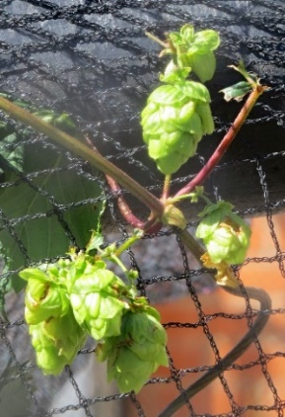 Our 2017 Hop Crop

Developments: cleansing room and tool shed

During the past few months we have been working on the exterior of the Cleansing room, a slow careful process due to the old lead based paints. The fumigation room (possibly used for luggage fumigation) near the mortuary has been cleaned out and has relieved some pressure on our workshop / tool area. Many thanks are extended to the Bruny Mens Shed and David Boyer for helping make a custom fitted new workbench.

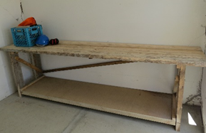
Our smart new Workbench

Science Fun Day 2016 and 2017

Last October’s Science Fun Day was a huge success. Over 100 people braved the drizzle to explore our science activities. Parks Tasmania, the Australian Government, volunteers and many other businesses provided excellent support. After positive feedback we have decided to run a similar event this October (This fits nicely with the historic science based functions of the Station). More details will follow, Please set aside Sunday October 15th. 2017 to bring your lunch friends and family across to solve some science puzzles and possibly win a prize!

The German Diary

Our diary continues to captivate visitors. We have been lucky to secure a professional display cabinet to exhibit a copy of the diary.

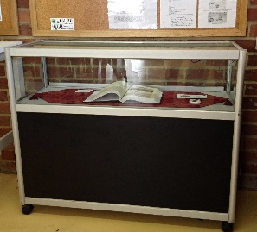

Our German Diary Copy on Display

Working Bee(s)

A big thanks is extended to parks and volunteers for their working bee effort on 6th September 2016. Lots of jobs were completed, much wood was split, the car park developments were completed, many more jobs were listed and many potential fire hazards were eliminated.

The committee is planning a working bee for this May and we would appreciate many hands, new volunteers are welcome. Details will appear soon.

New Opening Hours

We are trialling a five day per week opening regime during Winter this year. (When daylight saving is OFF). This has been prompted by increased visitor numbers. Many thanks to all our caretakers this past Summer and into this new Winter.

Compiled by Rob Banfield Publicity Officer

