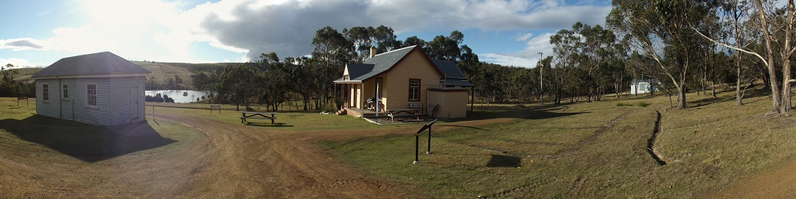

Bruny Island Quarantine Station Newsletter Winter 2016 p.1 Papage 1

German Diary Arrives!
As many Quarantine Station (Q.S.) enthusiasts will know, a very important event in the life of the station happened at the start of World War 1. Several German merchant seaman were unlucky enough to find themselves interred at the Q.S. when loading their cargo of timber at Port Huon! Jumping ahead to 2014, Kathy Duncombe was involved in an email interview with the German magazine”Geschimagazin” in the hope of tracking down some descendants of these important people who arrived on Bruny in 1915. This year we saw positive results in a contact with Roswitha Muller, from Germany, granddaughter of Fritz Stegherr. Fritz had kept a diary of his entire internship during WW1 and Roswitha has now sent the diary to the FOBIQS on a perpetual loan agreement to enable translation of this era of the station's history over 100 years ago. It includes some photos of the station that have never seen the light of day before, including some delightful sepia images taken from deep within Shelter Bay looking towards the centre of the Quarantine Station complex. (photo Kathy Duncombe)
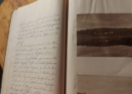

Science Fun day at Q.S.
FOBIQS will be hosting and organizing a prize laden fun science day on Sunday October 16th. at Q.S. We have been successful in gaining a grant from the Federal Government “Inspiring Australia” initiative to engage the general public in science. The event will be free and numerous prizes have been donated by local sponsors. Starting at 11 a.m.people will be able to move around 12 different science activity sites on the Station to gather letter clues to solve a small puzzle. All disciplines of science will be involved with easy hands on fun activities. Please pass the word around...free BBQ facilities will be provided and all prizes will be awarded on the day!!! Science dayinformation is also available on our Facebook page https://www.facebook.com/brunyquarantinestation/

The Wall!
This year we have been busily completing the new Interpretation Centre which is located in the 1970’s “Headhouse” on the Station precinct. We were very fortunate to have original red bricks donated to complete a small retaining wall at the rear of the Headhouse. John Lampkin from Bruny Landscaping assisted FOBIS with his amazing bricklaying skills.( pictured here, photo supplied by volunteer Craig who also offsided as a brickies labourer!) The retaining wall provides some valuable occasional seating on those hot sunny Bruny days and we thank John for his work!
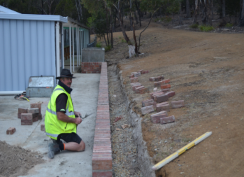

Car park development
As visitor numbers continue to increase we need to cater for many more vehicles. The new entrance will minimise traffic movement through the 1884 heritage buildings. Many thanks are extended to Parks staff and Nathan Lampkin for their assistance in developing a new access to the old car park. (picture by Peter Williams)
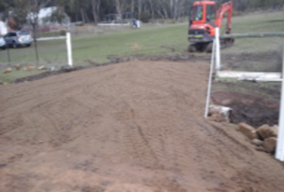

p.2

ABC Visits!!
Recently Chris Wisbey from the Australian Broadcasting Corporation visited the Quarantine Station and spoke with our President Kathy (pictured outside the old mortuary building, photo by Suzanne Smythe). Chris interviewed Kathy and was fascinated by the long and exciting history of the station.
Chris has told us that he expects toplay his Quaratine Station interview on ABC radio after the Olympic Games.
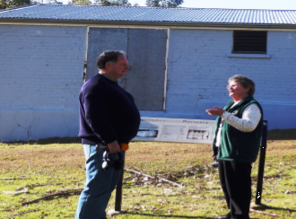

Summer Caretakers
Just a brief reminder to friends that we are taking applications for our summer caretaker program at Q.S. Please spread the word, application details are available on the Wildcare site, via previous emails and from Kathy or myself.

Editors note: After spending two days producing a polished Publisher version of this same newletter I realised it “cost” 14 megabytes to save!!...and of course it was impossible to email quickly…so here we are with the older less costly Word format..any feedback on process or output is happily accepted.

Rob Banfield

…..Inside our new Interpretation centre…….

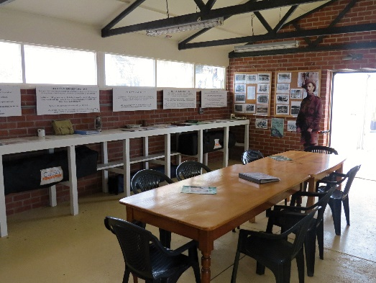

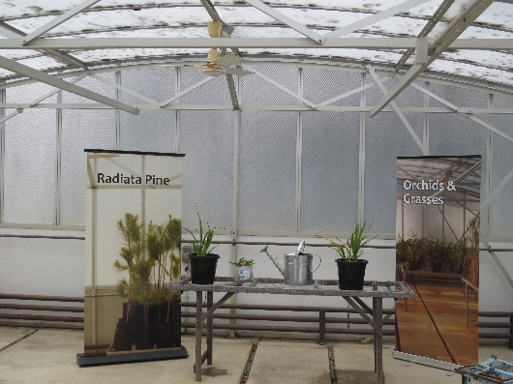

…and our glasshouse looks impressive at night …

