Bruny Island Quarantine Station
Volunteer Caretaker Summer Program
April 2015 to October 2015

INFORMATION AND APPLICATION FORM

Quarantine peninsula as seen from near Roberts Point

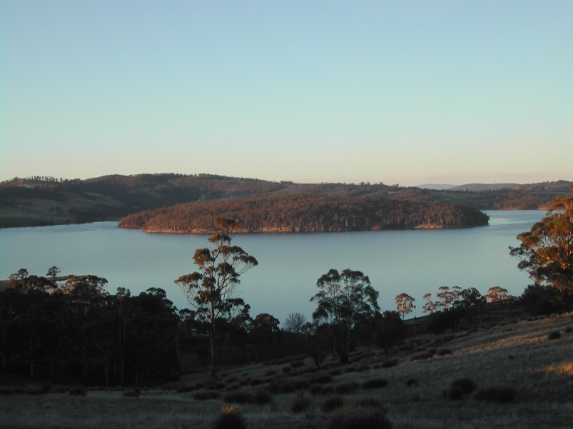
Introduction
The Quarantine Station Volunteer Caretaker Program on Bruny Island provides opportunities for volunteers to enjoy living on a peninsula extending into Barnes Bay in a heritage listed cottage originally built for the Medical Superintendent in 1884.
Volunteer Caretakers will provide a physical presence at the Quarantine Station, open the Station to visitors on weekends (closed Monday to Friday), provide visitor information about the heritage self- guided walk, provide other information about the natural history of the area, carry out minor maintenance and assist with coordination of other Parks and Wildlife Services (PWS) and Friends of Bruny Island Quarantine Station (FOBIQS) activities at the site.
A stint at the Quarantine Station could serve as an ‘apprenticeship’ for those people seeking volunteer positions at more challenging PWS locations such as Melaleuca, Deal Island or Maatsuyker Island.

About Bruny Island Quarantine Station
The Quarantine Station consists of a peninsula of 128 hectares extending into Barnes Bay at Bruny Island. Although a peninsula the Station looks and feels like an island.

The people of the Nuenonne Aboriginal Tribe were the traditional owners of Bruny Island, Van Diemen's Land including the land now occupied by the station.
Eras of the Quarantine Station are:
- Pre 1830 – Traditional owners
- 1856-1884 European settlement
- 1884-1908 State quarantine
- 1908-2002 Commonwealth quarantine includes:
  - 1914 - German prisoner of war internment
  - 1919 – Influenza pandemic
  - 1950s -1968 Plant quarantine
- 2003 – State Government responsibility Parks and Wildlife Service
- 2011 – Friends of Bruny Island Quarantine Station formed as a group for the purpose of: “Support the management, conservation and public appreciation of the Bruny Island Quarantine Station”.

Program Dates and Duration

The program of 7placements will commence on Thursday 2nd April and conclude on Thursday 15th October. Please note that there is some flexibility around the timing of placements particularly if potential caretakers have skills that would enable them to undertake priority tasks.

Volunteer Caretakers will be asked to cover a four-week block opening weekends and public holidays with the change-over day being a Thursday. The Station gates will remain closed from Monday to Friday. (Please note that on Sunday 4th October daylight saving commences and the Station will then be open 5 days – closed Tuesdays and Wednesdays). Having the gate closed prevents vehicle access although caretakers will need to appreciate that the Quarantine Station Reserve is open to the public and there are no restrictions on pedestrian access provided visitor behaviour is appropriate.
Although the gates are closed during weekdays arrangements will be made to permit special groups access to the site subject to the convenience of the caretakers. FOBIQS members will also assist as required for group visits if the caretakers are not available due to other commitments.
Outgoing Volunteer Caretakers will be asked to brief the incoming caretakers along with a person from PWS and FOBIQS.

Volunteer Caretaker Duties will include:
- Opening the gates to the site and displaying welcoming flags at gate and jetty area on weekends and public holidays;
- Meeting and greeting visitors and providing information about the Station;
- Monitoring and recording visitor numbers and impact and conduct visitor surveys if required;
- Maintaining an obvious presence to protect the site from inappropriate behaviour by visitors and communicating with PWS Bruny Island on any issues of concern;
- Carrying out minor maintenance tasks as identified in the approved work program;
- Acting as first response in the event of emergency and make room for communication hub if needed;
- Reporting issues such safety hazards and bushfire risk to PWS Bruny Island staff including display of Total Fire Ban sign when required; and
- Other tasks identified and appropriate to the capacity of individual Volunteer Caretakers.

Volunteer Caretakers will not be required to:
- Be involved in any law enforcement activities, or confront visitors over any such issues, unless there is an immediate risk to personal safety.

The Parks and Wildlife Service will provide:
- Accommodation at the ‘Doctor’s Residence;’
- Support by phone and in person as needed;
- Emergency communications;
- First aid kits;
- Any Personal Protective Equipment (PPE) tools and equipment necessary for minor maintenance duties; and
- Items of clothing to identify Volunteer Caretakers (VEST, hat and name badge).
- Voucher for one return ferry trip Kettering to Bruny Island.

Volunteer Caretakers will be expected to provide:
- All food for the duration of their duty;
- All clothing apart from uniform items (see above);
- Sturdy work boots
- All bedding and linen; and
- Own vehicle for transportation to Quarantine Station.

Accommodation
Volunteer Caretakers will be accommodated in the ‘Doctor’s Residence’. The building is a modest timber one-bedroom house with the following facilities:
- Well-appointed kitchen with all utensils, electric hot water, refrigerator, microwave and stove;
- One bedroom with queen size bed and two single beds;
- External, attached bathroom with hot shower, hand basin and toilet;
- Lounge room with wood heater, library and television;
- Verandah looking over Shelter Cove;
- Mains electricity
- Telephone – mobile for incoming calls (voice and text) and outgoing – TEXT only;
- External laundry with washing machine and basin; and
- Shared toilet
- Parking close to the quarters

The Volunteer Caretakers will have sole occupancy of the Doctor’s Residence. However, on occasion FOBIQS members, PWS and visitors may wish to use the toilet attached to the house. On occasion PWS Staff/FOBIQS may, when on site require access to the kitchen facilities.

Qualifications and Selection Criteria
Volunteer Caretakers will not require specialist or trade qualifications. General knowledge of the area, communication skills and practical skills will be useful. If, however, you have specialist qualifications that you consider may be useful (eg carpenter, electrician, chainsaw operator, coxswain) please advise us on the program application form. Special skills in arts, culture and sciences, education (eg writing, painting, composing, botany) are highly regarded and should also be mentioned.

Volunteer Caretakers will be selected according to how well they meet the following selection criteria:
- Ability to live and work in a semi-remote location, with limited ‘home comforts’ for the four-week period;
- Ability to communicate well with a broad range of visitors expected at the Quarantine Station;
- Knowledge of, or the ability to rapidly acquire knowledge of, the cultural and natural history of the Bruny Island Quarantine Station;
- Possessing a broad range of practical skills appropriate to undertake routine maintenance tasks;
- Ability to work with a range of other FOBIQS volunteers on larger projects at the site; and
- First aid qualifications or medical knowledge highly desirable for at least one member of each team.

Induction
The Parks and Wildlife Service and accredited FOBIQS members will conduct induction and familiarisation sessions for caretakers on site at the Station on the Thursday of commencing the placement.
All applicants are encouraged to join WILDCARE and nominate FOBIQS as interest and to attend one (or more if you wish) working bees conducted by FOBIQS during the year. This will provide an opportunity to assess the accommodation and the ambience of the station to help determine if a volunteer posting would suit you. Working bees are held by FOBIQS on designated Saturdays and Tuesdays.

Occupational Health and Safety
The provision of a safe working environment and safe working procedures is mandatory for all works carried out by PWS. The Volunteer program at Quarantine Station will be carried out according to all current safe-working guidelines. Volunteers will be made familiar with these procedures during the Induction and will be expected to adhere to them.

Conditions of Engagement in Volunteer Program
All people volunteering with Parks and Wildlife Service are required to conduct their duties in accordance with the State Service principles and Code of Conduct. Agency expectations will be explained at the Induction.

How to Apply
If you are interested in taking part in the Volunteer Caretaker Program, complete the Application Form included with this information package. Please be aware that completion of the application form does not guarantee a place on the program.

Closing Date
Applications for the initial placements in the Program will close on Friday 13th February 2015.

Further information

For further information about the Quarantine Station and any questions about the facilities please contact the President Friends of Bruny Island Quarantine Station (Kathy Duncombe) by landline 0362606287 or mobile 0427050395 or by email kdunc@netspace.net.au
There may be options for shorter or longer placements and it may also be possible to arrange for FOBIQS members to cover for a weekend if caretakers need to leave the Station to attend to matters of pressing necessity. Please discuss these issues with Kathy Duncombe.

Selection
All applications will be assessed by a three person panel of PWS and FOBIQS nominees. Applicants will be notified if they have been successful by 23rd February 2015.

Department of Primary Industries Parks Water and Environment

Quarantine Station State Reserve
Summer Volunteer Caretaker Program 2015

APPLICATION FORM
Each person or couple applying must complete an Application Form
Couples please include comments from each of you in the Selection Criteria

VOLUNTEER 1
Surname Given Name/s

Age last birthday Preferred name

Residential address Postcode

Postal Address (Only if different)

Phone: Home Work Mobile

Email:

WILDCARE 2015 membership number:

VOLUNTEER 2
Surname Given Name/s

Age last birthday Preferred name

Residential address Postcode

Postal Address (Only if different)

Phone: Home Work Mobile

Email:

WILDCARE 2015 membership number:

EMERGENCY CONTACT DETAILS
Name Relationship to person

Address

Phone(s)

PREFERRED SESSION(S) IN 4 WEEK BLOCKS

Please number 1 – 6 in order of preference or stipulate a specific session (s) that you are available for.
Date Start | Date Finish | Preference 1-6
2nd April | 30th April
30th April | 28th May
28th May | 25th June
25th June | 23rd July
23rd July | 20th August
20th August | 17th September
17th September | 15th October

INDUCTION AND CHANGE OVER
Induction will be provided onsite on the Thursday of commencing the placement. All Caretakers are required to attend this induction. Site induction will be conducted by appropriate PWS staff member and or an accredited FOBIQS member

REFEREES
Please provide the details of two people who could comment on your suitability to undertake the type of volunteer activity requested.

Name Contact Details

Name Contact Details

PLEASE ADDRESS EACH OF THE FOLLOWING SELECTION CRITERIA

- Provide a brief outline of why you would enjoy living in a semi-remote location and any experience you have of a similar nature.

- Provide evidence of your ability to communicate with the broad range of visitors expected at Quarantine Station

- Provide evidence of your knowledge of the cultural and natural heritage of the Quarantine station.

- Describe what practical skills you would be able to apply on site. (Include details of any current trade tickets.)

- Demonstrate ability to work in a team situation with other volunteers.

LEVEL 2/SENIOR FIRST AID CERTIFICATE
(Desirable but not required)
Do you hold a current First Aid Certificate? YES/NO Expiry Date
If yes, please attach a copy of your current Workplace level 2 First Aid Certificate or equivalent with this application.

MEDICAL DISCLOSURE
The Department of Primary Industries, Parks, Water and Environment values the safety and well-being of employees, volunteers and others with whom we have a relationship in our places of work. We aim to minimise the risk of injury and ill-health by providing safe workplaces.

To assist the Department in this regard, applicants selected for the program will be asked to provide information giving details of any medical condition that may impact on their capacity to undertake the duties expected or affect the safety of others. This form must be completed before commencing duties and taken with you to the induction session at the Station. You will not be asked to complete this form if you are unsuccessful in your application.

DISCLAIMER
The Department’s Personal Information protection policy ensures management of personal information is in accordance with the Personal Information Protection Act (2004).

Do you consent to the Department using your personal information for the purposes for which it has been provided and for summarised general reporting on volunteering activities?
Yes No (please circle)

By completing this form I agree to be available for an induction session at the Quarantine Station on the day of commencing the placement or at another time arranged.

The Information provided is correct to the best of my knowledge:

Signed 1 __________________________________ Date _________________

Signed 2 __________________________________ Date _________________

FORWARD COMPLETED APPLICATION by email TO:
Secretary FOBIQS – peterfwill@gmail.com Mobile telephone 0418122039
If emailing the application is a problem please telephone and discuss options.

CLOSING DATE: Friday 13th February 2015.Thank you for your interest. All applications will be acknowledged and applicants advised of the outcome of their application by 23rd February 2015 thus providing approximately 6 weeks notice for the initial caretaker(s).

